**Software Engineering Project  
“Lexia”**



Group 1

Juan Jonathan 2106704894

Lauren Christy Tanudjaja 2106707870

Zaki Ananda 2106705474

**Program Studi Teknik Komputer**

**Fakultas Teknik**

**Universitas Indonesia**

**Table of Contents**

**Chapter 1 - Introduction 4**

1.1 Background 4

1.2 Purpose 4

1.3 Literature Review 5

1.3.1 Client-Server Game Architecture 5

1.3.2 Client-Side Prediction 5

1.3.3 Server Reconciliation 6

1.3.4 Language Flow 7

1.4 Similar Competitors 8

1.5 Tools 9

1.5.1 Typescript 9

1.5.2 Godot 10

1.5.3 Docker 10

1.5.4 Figma 11

1.5.5 Kenney Assets 12

1.5.6 Freesound.org 12

1.5.7 Visual Studio Code IDE 12

**Chapter 2 - Project Management 15**

2.1 Roles and Responsibilities 15

2.1.1 Juan Jonathan - Project Coordinator and Tester 15

2.1.2 Lauren Christy - UI/UX and Asset Designer and Front-End Programmer 15

2.1.3 Zaki Ananda - Game Designer and Back-End Programmer 15

2.2 Schedule and Planning 16

2.2.1 Schedule Overview 16

2.2.2 Details 16

2.3 Risk Management 17

**Chapter 3 - UML Diagrams and Design 18**

3.1 Class Diagram 18

3.2 Use Case Diagram 20

3.3 Deployment Diagram 21

3.4 Activity Diagram 22

3.5 Design 22

**Chapter 4 - Implementation 25**

4.1 Back-End 25

4.1.1 User Data Schema 25

4.1.2 User Login 25

4.1.3 User Register 26

4.1.4 User Progression Tracking 26

4.2. Game Script 26

4.2.1. Player Movement 26

4.2.2. Map Triggers 28

**Chapter 5 - Test Plan and Testing 30**

5.1 Introduction 30

5.1.1 Scope 30

5.1.1.1 In Scope 30

5.1.1.2 Out of Scope 32

5.1.2 Quality Objective 33

5.1.3 Roles and Responsibilities 33

5.2 Test Methodology 34

5.2.1 Overview 35

5.2.2 Test Levels 35

5.2.3 Bug Triage 37

5.2.4 Suspension Criteria and Resumption Requirements 38

5.2.5 Test Completeness 40

5.3 Resource & Environment Needs 41

5.3.1 Testing Tools 41

5.4 Terms/Acronyms 43

**Chapter 6 - Final Test Result 45**

6.1 Unit Testing Result 45

6.2 Integration Testing Result 47

6.3 Regression Testing Result 53

6.4 User Acceptance Testing 55

**Chapter 7 - User Manual 59**

**Chapter 8 - MoU 60**

**Chapter 9 - Future Work and Closing 64**

9.1. Future Work 64

9.1.1. Achievement System 64

9.1.2. Additional Gameplay Elements 64

9.2. Closing 64

**REFERENCES 66**

# 

# **Chapter 1 - Introduction**

## 1.1 Background

This document outlines the Lexia project, an application created with the primary purpose of assisting individuals with dyslexia. Named "Lexia," this application takes a unique approach by presenting its dyslexia support features within an engaging gaming framework, aiming to make the learning experience more enjoyable.

Lexia serves as a valuable tool to help individuals with dyslexia improve their reading and writing skills. It achieves this by combining essential support features with entertaining gameplay. Notably, the application offers features such as word segmentation and a talkback function, which are specifically designed to facilitate easier reading and writing for dyslexic users.

The app which we are making will be a web-based application that runs on a browser. We chose a web-based application for it to be cross-platform and can run on multiple different operating systems. This also improves accessibility which will increase the playerbase of our game.

## 

## 1.2 Purpose

People with dyslexia often face challenges in their academic and personal lives, which can lead to feelings of self-consciousness and inadequacy. One of the most significant hurdles they encounter is the pressure of improving their reading and writing skills. The aim of the Lexia project is to alleviate this pressure and create a more enjoyable platform for individuals with dyslexia to practice and enhance their language abilities.

In Indonesia, despite the prevalence of dyslexia, comprehensive studies and solutions remain scarce to tackle this issue. According to the Asosiasi Disleksia Indonesia (ADI), the official dyslexia association of Indonesia, studies on dyslexia are still limited in scope compared to the extent of the problem. In 2020, ADI conducted a study involving 133 dyslexic children [1], revealing the urgent need for interventions and support. Dominantly male (101 cases, 76%). Most of them were diagnosed at the age of 4-6 years old (56.5%) and 7-9 years old (33.8%) with median age of diagnosis at 79 months. About 66 (49.6%) were primary school students and 53 (39.9%) were preschoolers. Results showed that 4 (3%) of children have mild dyslexia, 44 (33%) have moderate dyslexia, 56 (42%) have severe dyslexia, and 17 (13%) were at risk of dyslexia.

Dyslexia is a condition that can improve with consistent practice and support. Our project provides a nurturing and low-stress environment within a gaming format. By doing so, we aim to foster a positive attitude towards reading and writing, encouraging dyslexic users to embark on their learning journey confidently and enthusiastically.

## 1.3 Literature Review

### 1.3.1 Client-Server Game Architecture

Before implementing any game mechanics, it's crucial to remember that crafting a compelling single-player experience also requires thoughtful consideration to deliver the best gameplay immersion. Ensuring a fair and engaging experience for a solo player is paramount, and certain principles from multiplayer game design can be adapted for this purpose.

While cheating isn't a concern in single-player games in the same way it is in multiplayer, game developers still strive to maintain the integrity of the experience. Data communication is crucial in single-player games. Optimizing data transfer and resource management is vital to minimize potential lag or delayed experiences for the player. This includes efficient loading of assets, level streaming, and resource allocation to ensure a fluid gaming experience. [2]

Smooth gameplay hinges on efficient data communication and resource management. Optimizing data transfer, asset loading, and resource allocation helps prevent lag and delays, ensuring an enjoyable gaming experience. This optimization is particularly important for fast-paced games where responsiveness is key.

### 1.3.2 Client-Side Prediction

Some games are deterministic enough (the result of the given game state and set of inputs is completely predictable) that the clients can immediately process their inputs sent to the server. [3] While this eliminates delay and is accurate most of the time, synchronization issues might arise when clients have other things to do while executing their inputs. Let’s say a network has a delay of 100 ms and an animation of a character moving takes 100 ms. The naive implementation would process the whole in action in 200 ms:

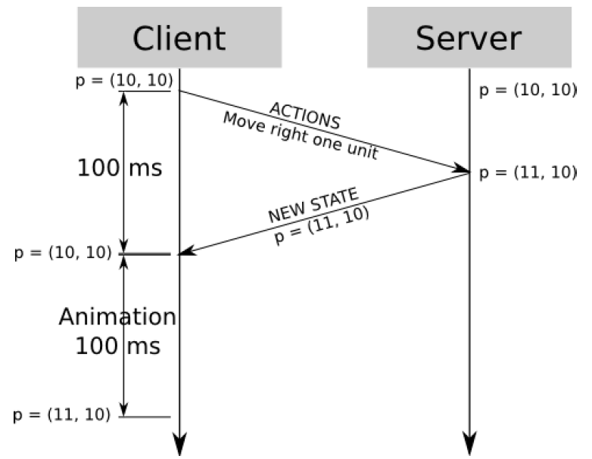

However, this gets tricky when the network has a delay longer than the animation. Let’s say the player wants to move two units to the right with a network delay of 250 ms. Using the previous technique, the following would happen:

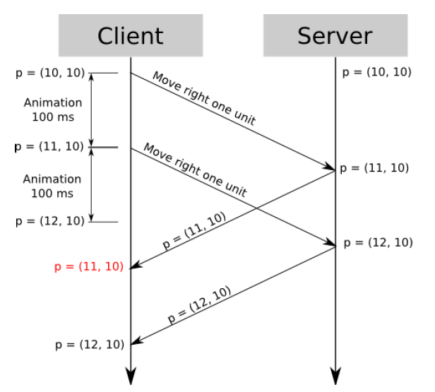

Notice at t = 250 ms, the client had already done their animation for the whole two units right movement, but the server had just finished its first update for the client, that is to move the right one unit only. Due to the server being authoritative, the client must revert its position back to x = 11. Not only that, at t = 350 ms, the client is also forced to update its position again, this time to x = 12. This phenomenon is called stuttering, which is the delayed update of the client’s data caused by the network delay that is longer than the client’s input process duration, which is unacceptable.

### 1.3.3 Server Reconciliation

Luckily, the synchronization issue mentioned above is not super difficult

to work around. The client first adds a sequence number to each request, namely

request #1 and request #2. [3] When this gets implemented in the previous case, this

would happen:

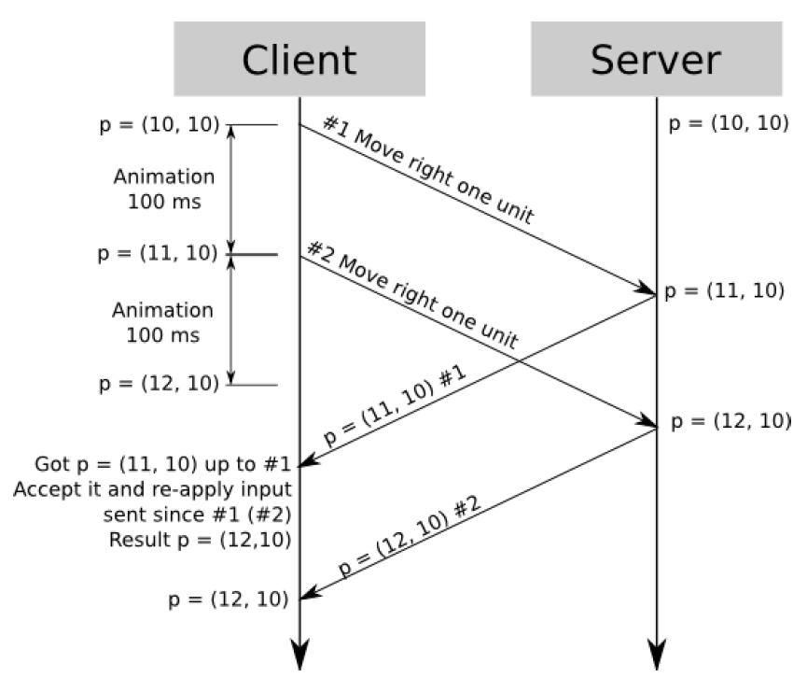

Now, at t = 250 ms, rather than resetting the client’s position back to x =

11, the client keeps their predicted position at x = 12 while still having x = 11 as

their legit position. Then, at t = 350 ms, when the server tells the client to set their

position to x = 12, the client is already there. This is a great illusion to conceal

high latency networks with fake responsiveness.

### 1.3.4 Language Flow

Understanding smooth transitions is crucial in our language learning design as it represents another aspect of user engagement. When a player is progressing through language exercises, it becomes essential to consider the fluidity of their learning experience.

Language Flow is a technique aimed at enhancing the player's representation of the language structure, aligning with the execution of their learning actions. Conceptually, Language Flow involves adapting the app's perspective to a previous moment, examining the specific language state when the user starts a specific exercise. [4] The algorithm functions in the following manner:

Before enacting a player's ongoing language exercise, the app:

* Calculates a reasonably precise understanding of the player's language proficiency.
* Analyzes the app's historical data (pertaining to the specific player) to identify the language exercises completed and received by the player just before the player intended to start a new exercise.
* Based on the aforementioned exercise (and the subsequent exercise determined by the exact target time utilized), it adjusts the exercise content to align with the player's proficiency level at that moment. This adjustment must factor in the user's learning progress and any extra assistance provided by the app.
* Allows the exercise to be completed, encompassing various language challenges, translations, and vocabulary exercises, which will contribute to the player's language learning progress.
* Provides feedback and assistance based on the adjusted exercise content, helping the player improve their language skills.

It's essential to note that during the step where we adapt the exercise to the player's proficiency level, there may be a necessity to adjust additional learning material as well (such as the complexity of the exercise, vocabulary difficulty, or grammar rules). The ultimate outcome of Language Flow is that each learner gains the ability to tackle language exercises at their appropriate level without feeling overwhelmed. However, it's important to acknowledge that this behavior involves a tradeoff in learning app design.

### 

## 1.4 Similar Competitors

This sort of topic has been attempted by various teams and researchers across the world. ‘Dyslexia Baca’, an educational game made by S. Daud et al. [5] is one that focuses on alphabet distinction, particularly one that looks similar to another (p vs b vs d, w vs m, etc.). Designed as a mobile game to sustain its user’s interest, it has received substantial feedback of around 4k+ downloads and a relatively positive review.

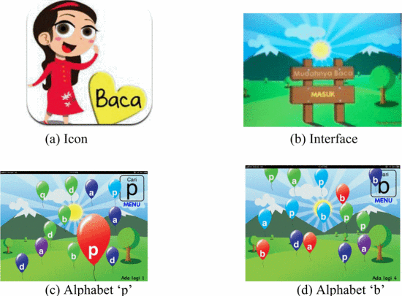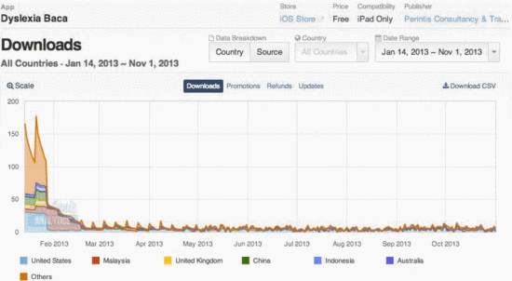

However, ‘Dyslexia Baca’ is with its faults. Over time, the number of downloads for this game has been gradually declining, as shown in the graph above. This decline could be attributed to various factors. This is where our game will outshine ‘Dyslexia Baca’ in a variety of aspects:

* Better player retention system

Our system focuses on enhancing the player experience and providing meaningful incentives to stay. We've implemented features that reward player loyalty, offer exciting new levels, and create a sense of accomplishment. As a result, players are more likely to keep coming back for more.

* More fun gameplay mechanics

We're committed to creating a challenging gameplay experience that respects players' skills and doesn't treat them like beginners learning to read and write.

* All-Age Friendly Gameplay

We're proud to say that our game is for everyone, not just kids. While our competitor's game seems to target children, our game is designed to be friendly to players of all ages.

## 1.5 Tools

Lexia will be initially developed as a local single-player game, which means it needs a dedicated server to store the player’s data and statistics. Besides that point, we also require some assets to complete the game with some artistic and musical skills. We include these tools we’ll be using in developing the application:

### 1.5.1 Typescript

Typescript can be used to create the game logic, such as the scoring system and the level progression, handle user input, such as the keyboard and mouse events, and communicate with the server. [8]

Node.js is an open-source, cross-platform runtime environment that allows developers to run JavaScript code outside of a web browser. [9] It is built on the V8 JavaScript engine and offers a powerful and efficient way to execute server-side and network applications. Node.js enables the creation of scalable, event-driven, and high-performance applications by utilizing JavaScript, a language traditionally associated with front-end development. This versatility makes it a popular choice for building various types of applications, including web servers, APIs, microservices, and real-time applications.

ReactJS is a powerful and widely-used open-source JavaScript library used for building user interfaces, especially for single-page applications where data updates frequently. [10] Developed and maintained by Facebook and the community, React allows developers to create interactive and efficient UI components that efficiently update and render based on data changes. With its component-based architecture and declarative syntax, React simplifies the process of designing complex and responsive web applications, making it a favorite among developers for creating engaging user experiences.

 

<https://nodejs.org/> <https://react.dev/>

### 1.5.2 Godot

Godot is a game engine that is used to create the graphics and sound effects for the game, create the user interface for the game, and animate the characters and objects in the game [6]. Godot is an open-source, feature-rich, and cross-platform game development framework that empowers developers to create captivating and interactive 2D and 3D games. Developed and maintained by the community-driven Godot Engine project, it provides a comprehensive set of tools and an intuitive visual editor for game creation. With its scene-based approach and node system, Godot simplifies the organization and management of game elements. It also supports multiple programming languages, including GDScript, C#, and VisualScript, enabling flexibility and customization in-game logic. Overall, Godot Game Engine is a popular choice among game developers for its versatility, performance, and ease of use in bringing game ideas to life.



<https://godotengine.org>

### 1.5.3 Docker

Docker is a container-based deployment utility, commonly used in systems that need scalability and continuous integration, and continuous deployment (CI/CD) environments [7]. A container will contain the application and the necessary dependencies (library, binary, configuration file, etc), completely isolated from the host machine, reducing the need to configure the hardware or virtual machine used to deploy the application software. These containers package software and its dependencies, enabling applications to run consistently across various environments, from development to production.

The core components of Docker include:

1. Docker Container

A lightweight, standalone, and executable software package that includes everything needed to run an application, including the code, runtime, libraries, and dependencies.

1. Docker Image

A read-only template used to create Docker containers. It encapsulates the application and its environment in a consistent and reproducible way.

1. Dockerfile

A text file that defines the instructions and configuration needed to build a Docker image. It specifies the base image, necessary packages, environment variables, and commands to set up the application.

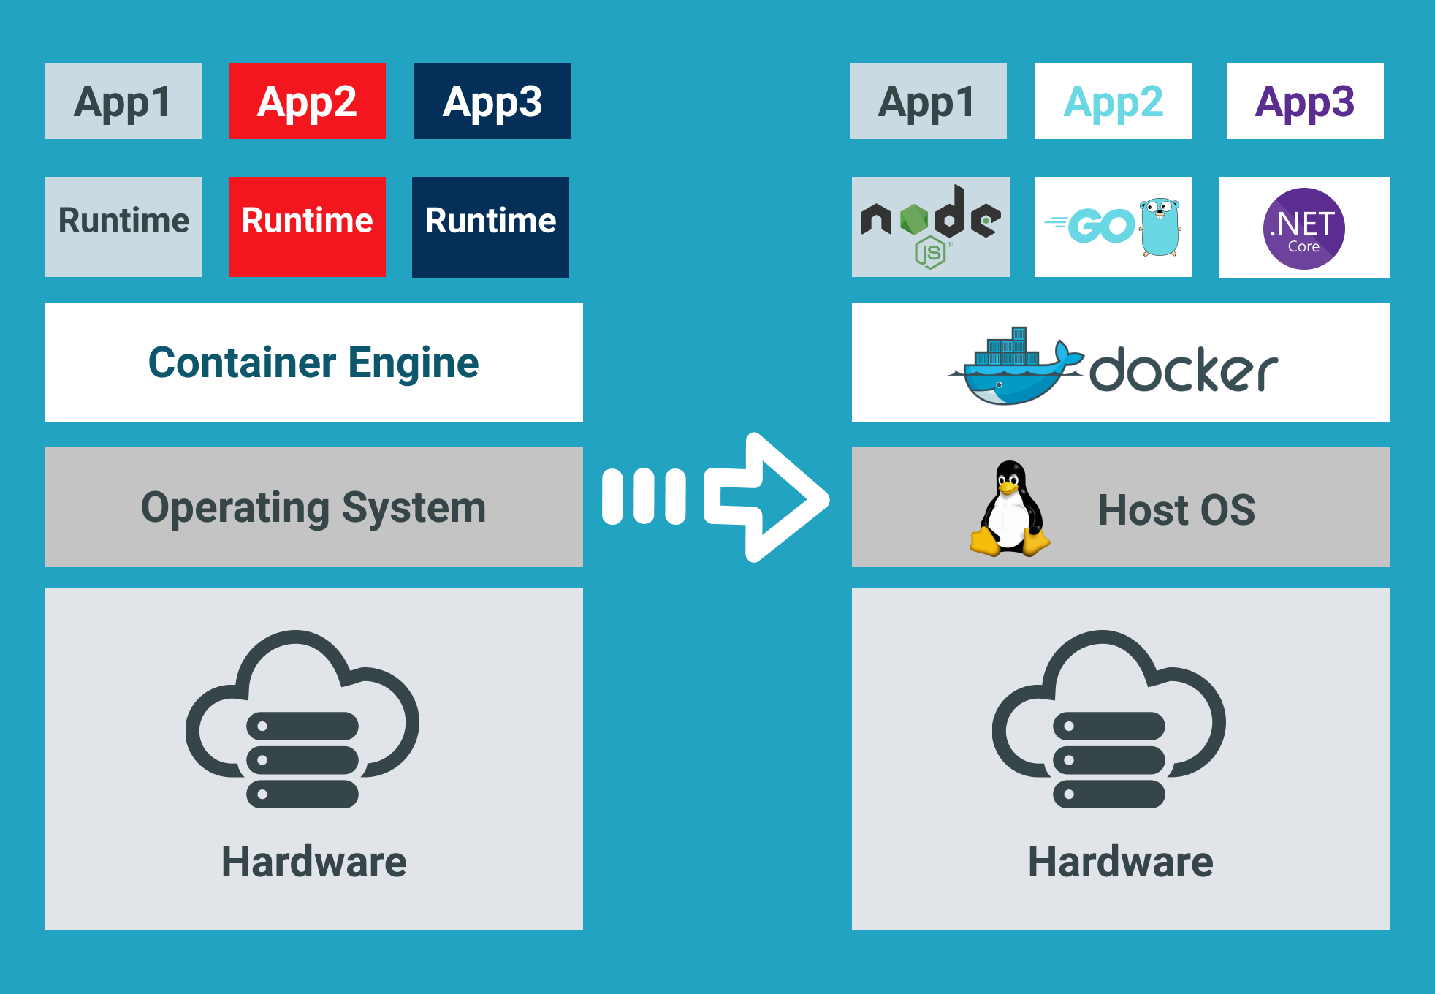

<https://www.docker.com/>

### 1.5.4 Figma

Figma is a popular cloud-based design tool used for creating user interfaces, user experience designs, prototypes, and collaborative design projects. It allows designers and teams to work on design projects in real time, fostering seamless collaboration and efficient design workflows. [11] Some of Figma’s features:

1. Cloud-Based Design

Figma is a web-based design tool that operates directly within a web browser, allowing designers to access and work on their projects from anywhere with an internet connection. It eliminates the need for installations and updates, ensuring that users always have access to the latest version of the tool.

1. Collaborative Design

Figma facilitates real-time collaboration, enabling multiple designers to work on a project simultaneously. Team members can view, edit, and comment on designs in real time collaboratively.

1. Design Components and Styles

Figma offers a robust system for creating design components and styles, promoting design consistency and efficiency. Designers can create reusable components and define styles for text, color, and effects, streamlining the design process and ensuring a cohesive design system.

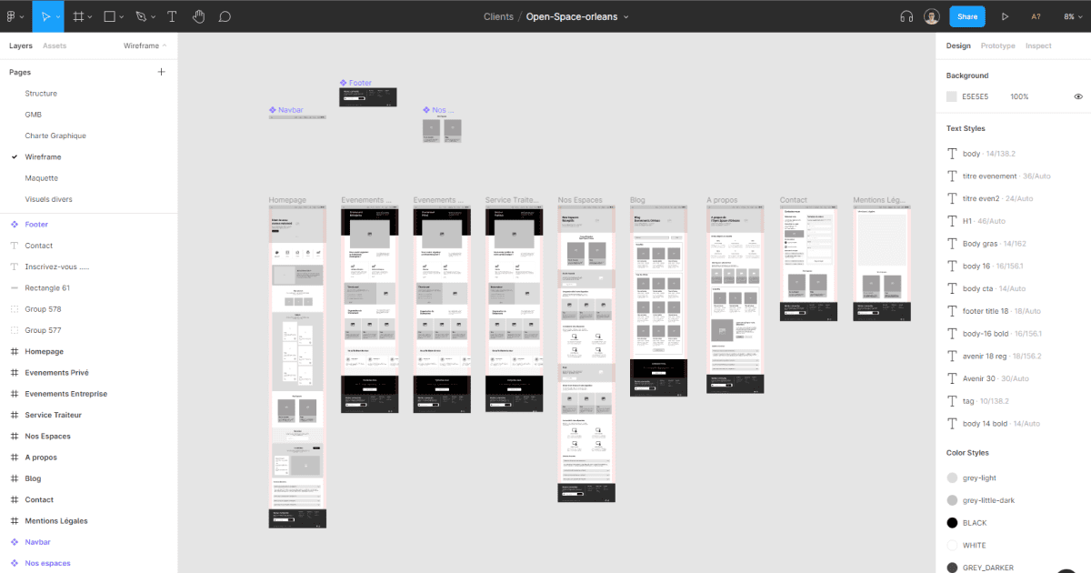

### 1.5.5 Kenney Assets

Kenney Assets provide free game assets to use for prototyping. This includes art, sound effects, music, and more. [17] Not only does this cut a huge portion of time in the production phase of the game, but it also makes prototyping easier resulting in more time to spend on polishing the game,



<https://www.kenney.nl/>

### 1.5.6 Freesound.org

To have more options in choosing the game’s sound effects and music, freesound.org is the way to go. Having over 500 thousand sounds available to download and more than 345 days of audio length, freesound.org can be the alternative to Kenney Asset in terms of game audio. [16]



<https://freesound.org>

### 1.5.7 Visual Studio Code IDE

Visual Studio Code is a powerful Integrated Development Environment (IDE) used by many developers worldwide. Its ability to add custom extensions will help the developer speed up development time. These extensions include code completion, debugging, docker containers management, integrated terminals, etc. [15]

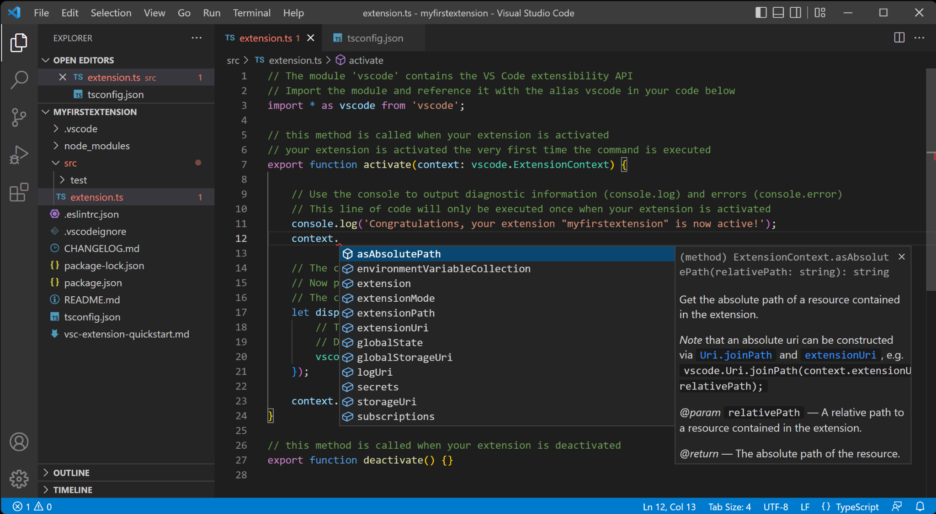

<https://code.visualstudio.com/>

1.5.8 Game UI Database

To give the best UI/UX for players, we take inspiration from other games that are of the same theme as us. This way, players can easily identify the game’s feel and connect with the game more deeply, which helps with player retention. [14]



<https://www.gameuidatabase.com>

1.5.9 Git and Github

Git is a widely used distributed version control system that enables tracking changes in source code during software development. It allows multiple developers to collaborate on a project simultaneously. Git records changes in a repository, allowing developers to create branches, merge code, and maintain a history of commits. [13]

GitHub is a popular web-based platform that provides hosting services for Git repositories. It enhances collaboration by offering features like pull requests, issue tracking, and project management tools. GitHub acts as a central hub for developers to share, contribute, and manage code efficiently, making it an integral platform in the software development community. [13]

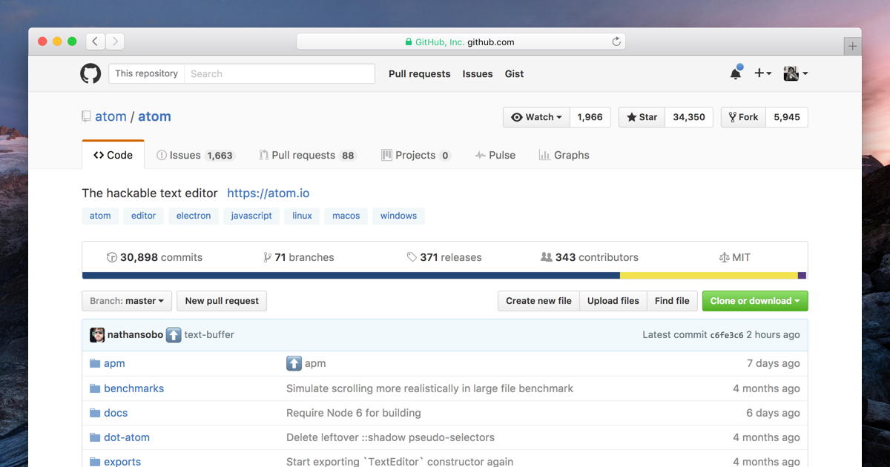

1.5.10 PostgreSQL

PostgreSQL is a powerful open-source relational database management system (RDBMS) known for its robustness, extensibility, and advanced features. It supports a wide range of data types and provides features like transactions, sub-selects, triggers, and views. PostgreSQL follows the SQL standard and extends it with features like JSONB data type for handling JSON data efficiently. It has a strong community and active development, ensuring regular updates and improvements. Additionally, PostgreSQL's scalability and support for complex queries make it a preferred choice for applications ranging from small projects to large, enterprise-level databases. [12]



# 

# **Chapter 2 - Project Management**

## 2.1 Roles and Responsibilities

Consciously and explicitly defining each person's role, responsibilities, and success criteria within the team can have an instant positive impact. It ensures that: Everyone knows what they're doing. It sounds simple, but when roles are clear, people know what's expected of them, how to behave, and what they need to accomplish. To ensure the project’s success, a team needs people fulfilling certain roles so one role doesn’t get overloaded with the workload and not produce a positive result.

### 2.1.1 Juan Jonathan - Project Coordinator and Tester

Responsibilities:

* Coordinate project schedules, resources, equipment, and information
* Break projects into doable actions and set timeframes
* Identify and define project requirements, scope, and objectives
* Ensure that objectives are met as the project evolves
* Test the program and looks for bugs

### 2.1.2 Lauren Christy - UI/UX and Asset Designer and Front-End Programmer

Responsibilities:

* Research resources and references for the style of the game
* Design the UI with user experience in mind
* Design the storyboard
* Search for art, sound effects, and music assets
* Assign all of the sound assets to the corresponding gameplay
* Implement front-end programming to ensure seamless user interactions

### 2.1.3 Zaki Ananda - Game Designer and Back-End Programmer

Responsibilities:

* Develop the initial prototype
* Develop and implement game software
* Ensure that the game design is fully implemented and works as expected
* Create the concept of the game

## 2.2 Schedule and Planning

### 2.2.1 Schedule Overview

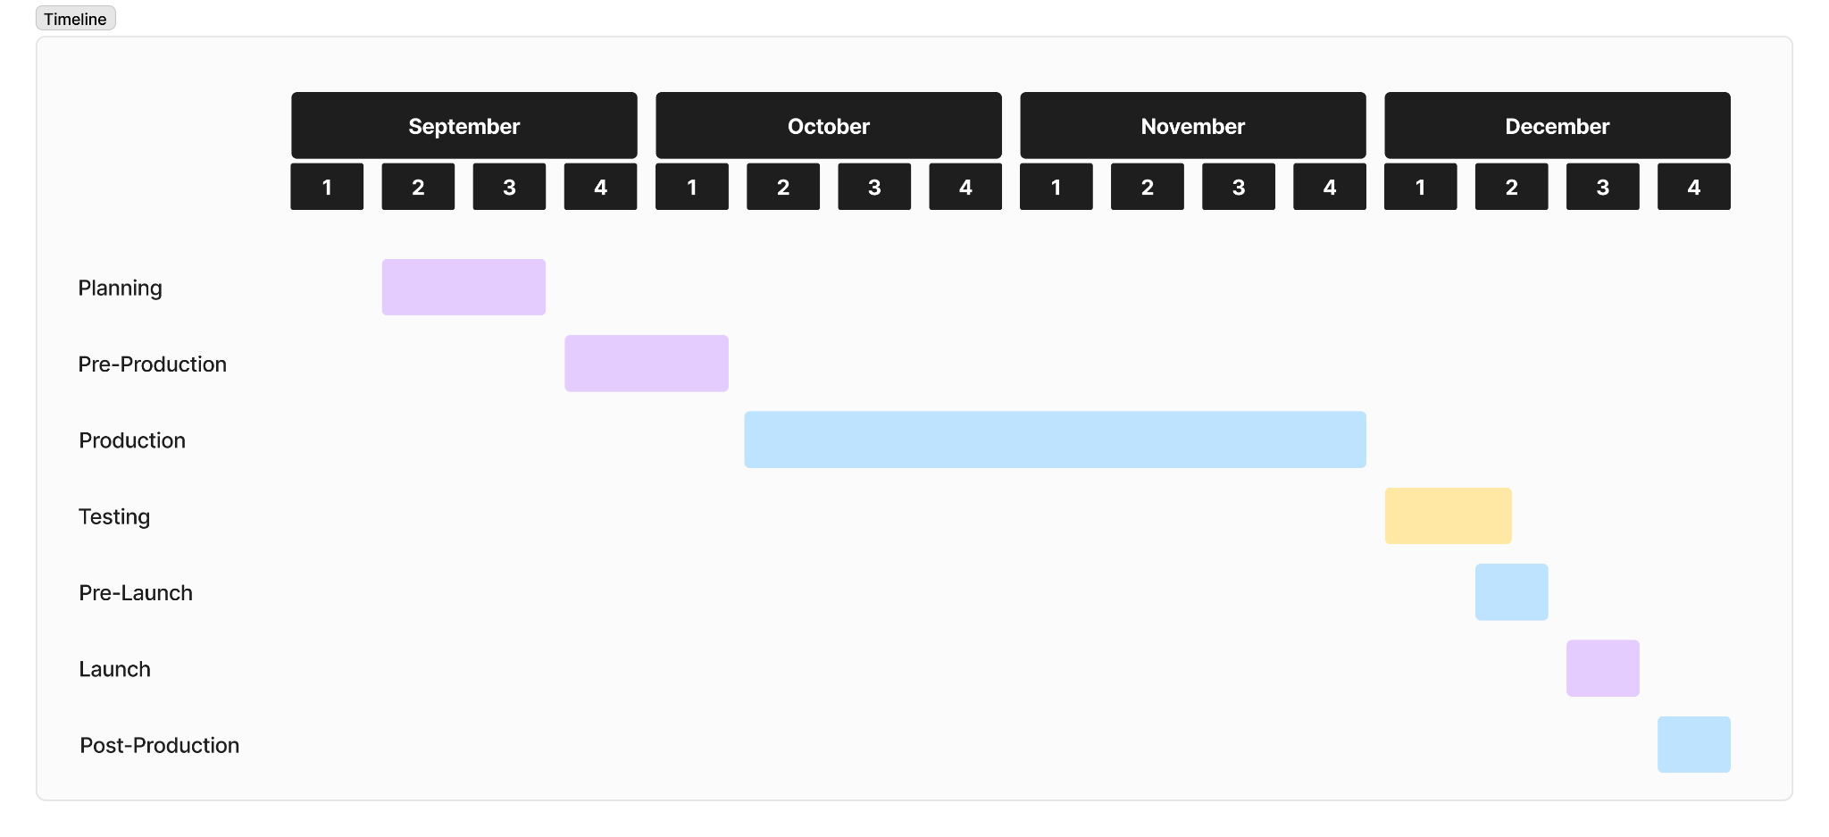

### 2.2.2 Details

Our group opted to use the classic waterfall model which is simple but idealistic. This model is the basis of all of the modern software development cycle models. This model divides the life cycles into a set of phases, where a phase is completed, the next phase can be started. These are the details of our timeline:

* Planning (11 September 2023 - 24 September 2023)

Before all of the members start to do their part, an idea of a video game has to surface. In this stage, all members brainstorm together to find a game concept. Basic questions like “What game are we making? Dimension? Key and wow features?” and everything else are discussed in this phase.

* Pre-Production (25 September 2023 - 8 October 2023)

The next stage will give life to the ideas that were laid out in the

planning stage. This is where all roles collaborate on the scope of the

video game and where each piece of the puzzle fits.

* Production (9 October 2023 - 31 November 2023)

This is the longest process in the cycle and most of the time, effort

and resources will be poured into this phase. This also happens to be the

hardest process which includes prototyping, audio designing, code

committing, and where every other part gets made.

* Testing (1 December 2023 - 6 December 2023)

Every feature and mechanic in the game needs to be tested for

quality control. A game that hasn’t been thoroughly tested is a game that’s

not even ready for an Alpha release. Some playtesters conduct stress tests

by running into walls hundreds if not thousands of times in an attempt to

“break” the game, while other playtesters conduct “fun factor” tests to see

if the game is too hard or too easy or complete the entire game to see if it

was satisfying enough.

* Pre-Launch (7 December 2023 - 11 December 2023)

This stage is where the game is revealed to the public and the team

is bombarded with thoughts and doubts. “How would people think of the

game? Will it be fun enough?” etc. Some upload the game betas during

this stage to get further input and give the game one last polish before it is

officially released. This also includes major bug hunting and squashing.

* Launch (12 December 2023 - 18 December 2023)

The wait is finally over and this is where the game is released. At

this stage, the game is launch and distribution-worthy.

* Post-Production (18 December 2023 - 25 December 2023)

Just because the game has been published, that doesn’t mean that the work is done. It’s not uncommon for video games to launch with batches of minor bugs. The first few months during the post-launch stage are typically spent identifying and squashing these bugs. Most gaming studios also rely on players to submit bug reports or speak up about bugs in online forums. This is all part of post-launch support.

## 2.3 Risk Management

The risks that might raise some concern:

* Gameplay-Affecting Bug

As with any software project, there is a risk of encountering bugs or technical issues that could adversely affect the gameplay experience, potentially hindering the application's efficacy for users with dyslexia.

* Lag and Latency

High latency or lag during gameplay could diminish the user experience, particularly for individuals with dyslexia who may require a seamless and enjoyable experience.

* Server Overload Risk

As the user base grows, there may be challenges related to server capacity and performance. These challenges could result in downtime or reduced service quality.

# 

# **Chapter 3 - UML Diagrams and Design**

## 3.1 Class Diagram

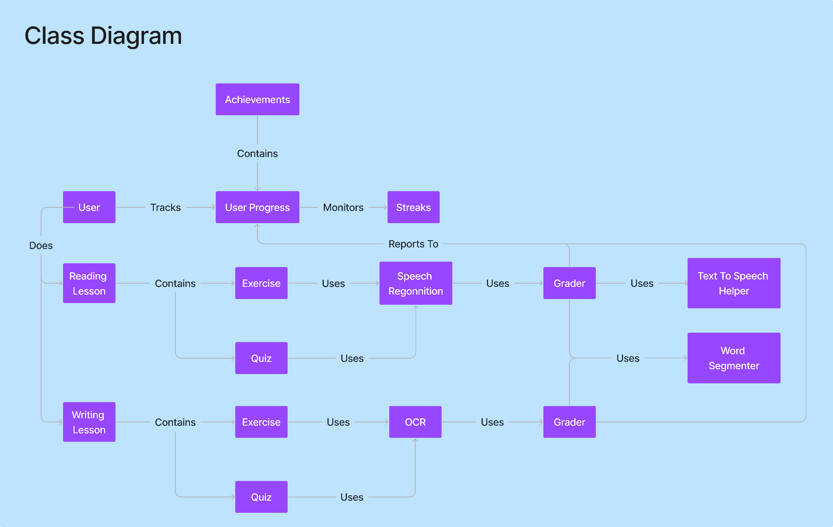

The provided class diagram represents how our web application’s structure will look like. Every class on the diagram represents an object that exists within the application:

1. User

User class will be where the user’s information will be kept, such as full name, username, date of birth, etc. User class will keep track of their own progress after the user does a reading or writing lesson. User progress will keep track of reading and writing lessons separately.

1. User Progress

User Progress class will be where the user’s progress will be tracked. Each user will have their own progression record as the web application will continuously report to this class after each grading session by the Grader class.

1. Achievements

Achievements class will be where the server keeps track of users’ achievements. Achievements will provide the user with extra incentives to keep playing as well as rewards for certain milestones in order to make the user feel their own progress.

1. Streaks

Streaks class will store data regarding the user’s daily streak in either reading or writing lessons. Better streaks would get more rewarding, to maintain user engagement.

1. Reading Lesson

Reading lesson class will store data regarding lessons in reading. It includes the necessary exercises and quizzes relevant to certain topics, focusing on reading proficiency skill

1. Writing Lesson

Writing lesson class will store data regarding lessons in writing. It includes the necessary exercises and quizzes relevant to certain topics, focusing on writing proficiency skill

1. Exercise

Exercises will provide the user with questions made by the developer in order for each user to build their skill. Exercises will be more relaxing as there is an incentive to learn but also less pressure. These will not determine the user’s skill level as those are reserved for Quizzes at the end of each level.

1. Quiz

Quiz will be provided at the end of each level as a method to measure the skill of the user and whether they can progress to the next lesson. These quizzes will provide the user with a recap of all the skills they learned with added difficulty.

1. Speech Recognition

Speech will be used by the user to answer reading lessons. As such, speech recognition will be the tool used by the Grader to convert the user’s speech to text such that their answer can be graded.

1. OCR

OCR will be used by the Grader to detect characters and words from a picture. Hence, the grader will be able to measure the user’s ability based on the answer they wrote.

1. Grader

The Grader will be used to measure the user’s performance on an exercise or quiz. It will take input from the Speech Recognition for reading lessons and OCR for writing lessons. The Grader will compare the user’s answer to the answer key and judge the user’s performance. Finally, it will report back to the User Progress Class.

1. Text to Speech Helper

The Text to Speech helper will be used to assist with difficulties in reading lessons. If the user is struggling, then text-to-speech will be played back to the user in order to give help via audio.

1. Word Segmenter

Word segmenter will be used to assist with difficulties in long-word comprehension. Segmentation will be done according to the word’s syllable, so word comprehension can be done on a per-syllable basis.

## 3.2 Use Case Diagram

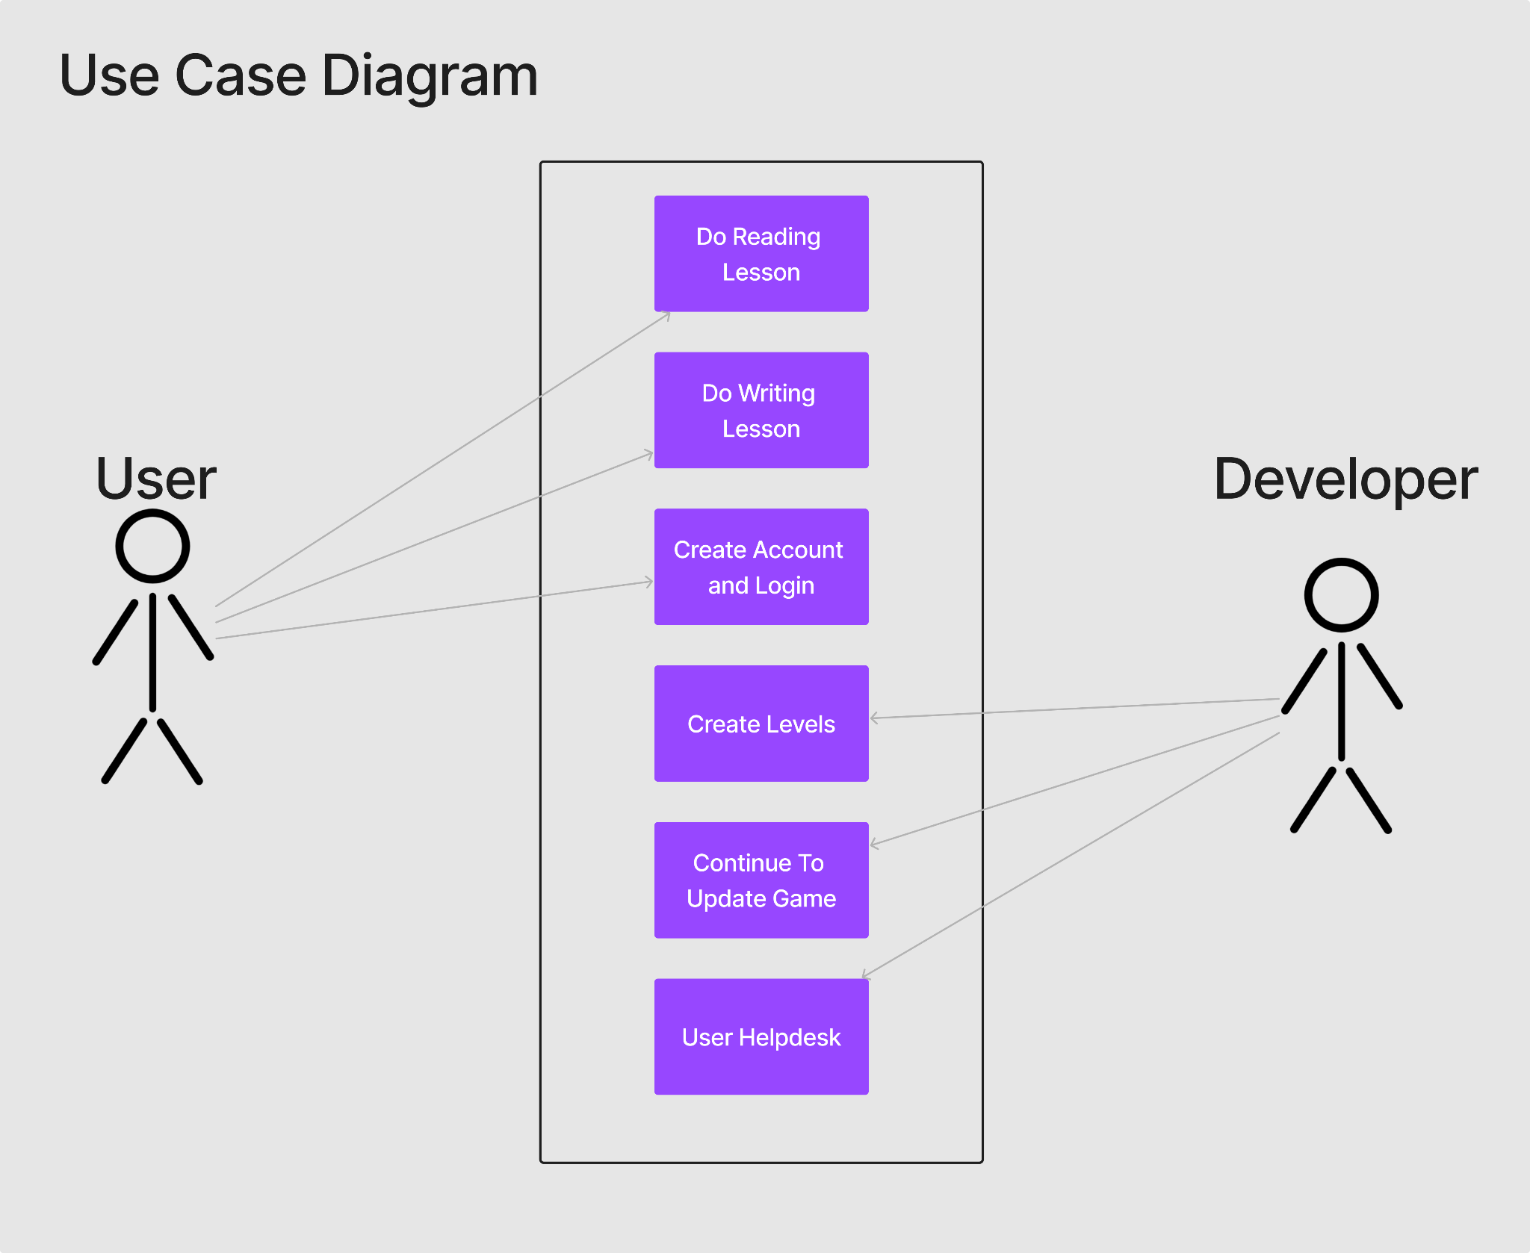

The use case diagram above is a representation of the features that can be done in the ‘Lexia’ game. The user will be able to create an account and log in. This will be done in order to keep track of user data for the web application’s full functionality. Each account will be able to keep track of the user’s progress, achievements, as well as streaks. Then, the user will be provided the option to do reading and writing lessons. These 2 tasks will be the core functionality of the web application. This will redirect the user into fully fledged levels, each with its own challenges for the user to overcome. The reading lesson will prompt the user with some text for the user to read. Meanwhile, the writing lesson will provide the user with some audio for the user to write. Their answers will be processed by the speech recognition and OCR tools. Finally, the grader will judge the user’s performance and report back the user's progress.

The developer’s duty is to continuously add levels in order to freshen the gameplay as well as continue to build the user’s skill. Updating the game from any bugs or other issues is also a must for the developers as software maintenance is a big part of the life cycle. Finally, the developers must be ready for any questions or other issues from the user and answer them accordingly, acting as a helpdesk or sorts.

## 3.3 Deployment Diagram

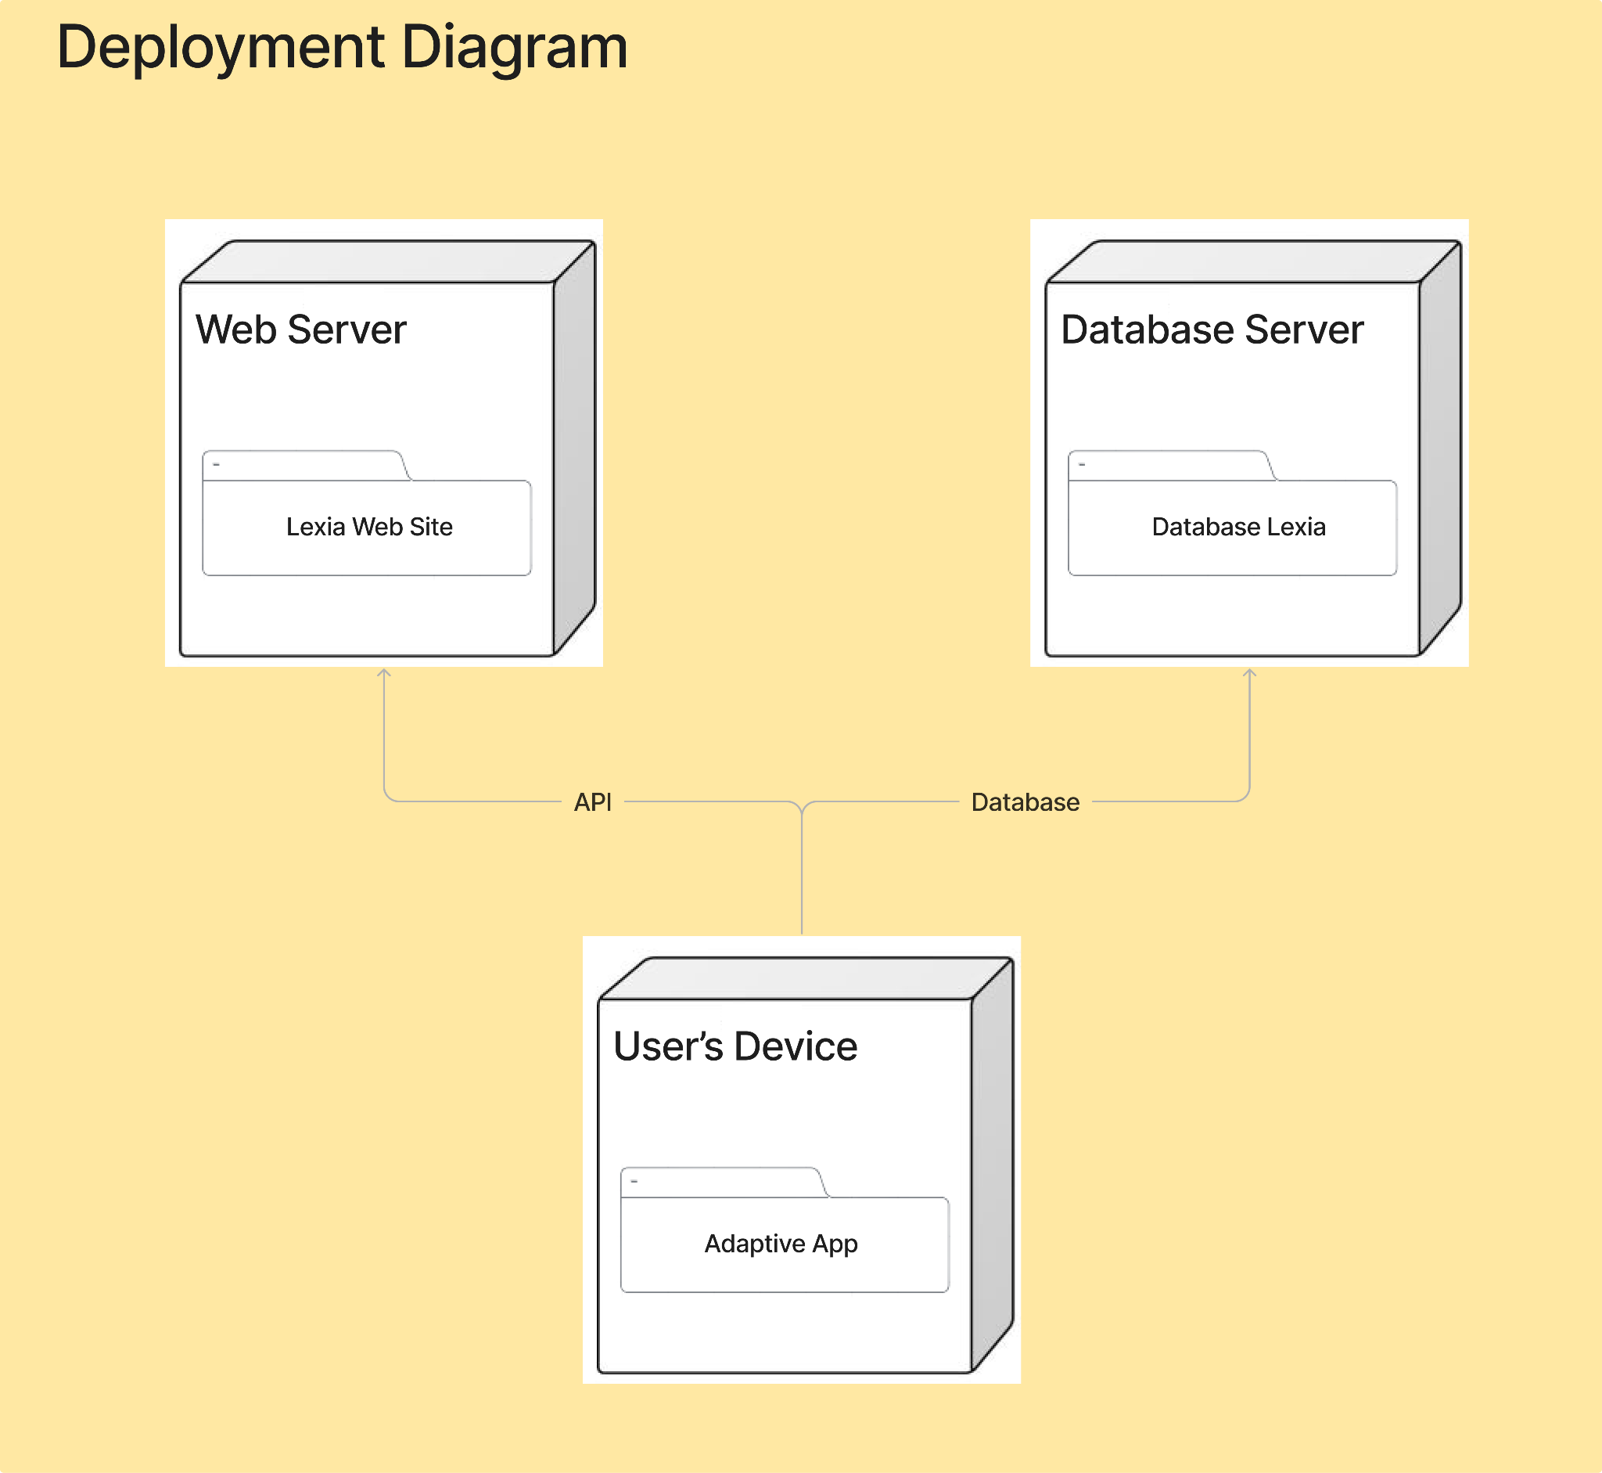

Lexia will consist of three different parts: web-server, database, and device application. The web-server and the database will be deployed by the developer, while the device application will be run on the user’s device.

The web server will be designed in TypeScript, utilizing various libraries and frameworks. The database will be designed in NoSQL and used to store various data, such as user accounts, progression, lesson data, various telemetry, and many more.

## 3.4 Activity Diagram

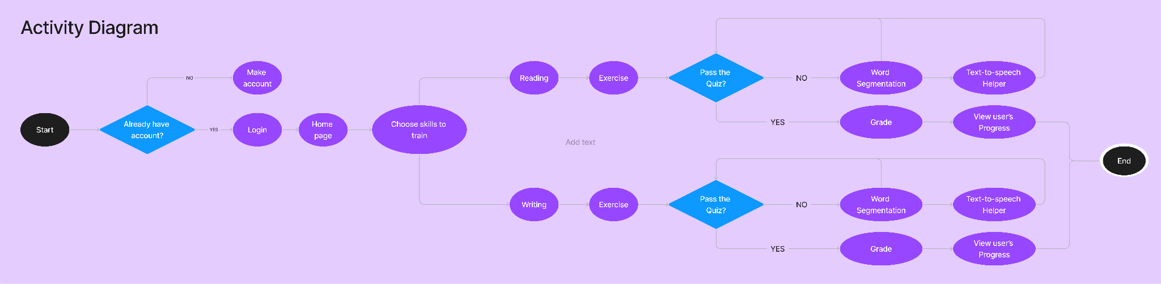

The application will start with a prompt for the user to log in to their account. If the user doesn’t have an account, then the user will have to make an account to progress. After that, the user will go to the web application’s home page where they can choose to take the reading and writing lesson. After that, they will be redirected to the lesson they chose. The lesson will be split between exercises and quizzes. The user can use exercises to practice and build up their skills. Meanwhile, the quizzes will determine the user’s skill and judge whether they can continue to the next level with higher difficulty or not. If they pass, the user can view their updated progress, return to the homepage, and continue to the next lesson. However, if the user struggles and does not manage to pass the quiz, then the web application will help the user via text-to-speech and word segmenter.

## 3.5 Design

Sign Up Page

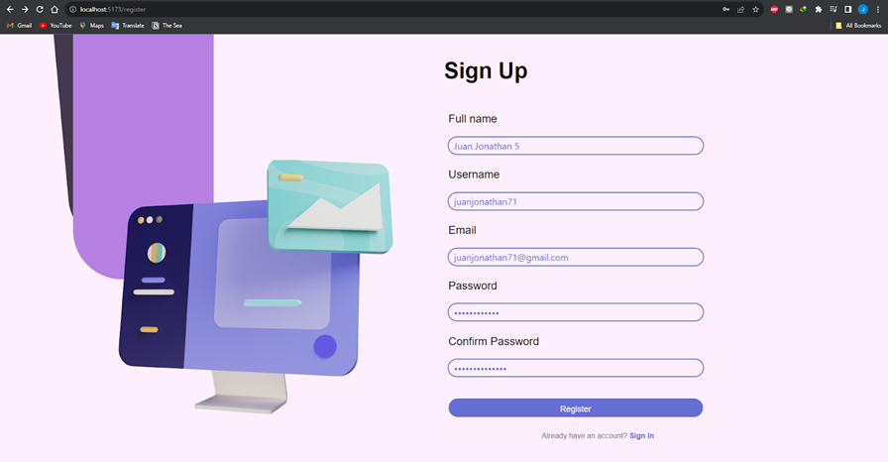

Login Page

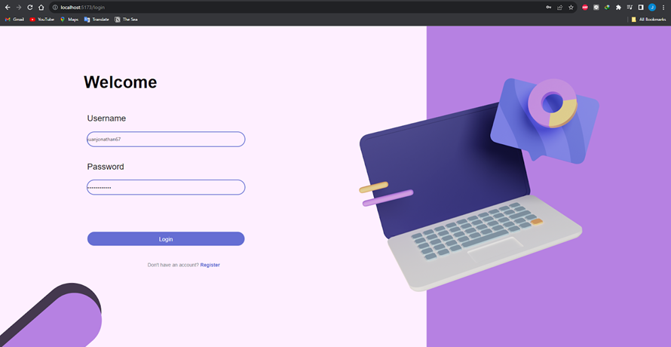

Map Design

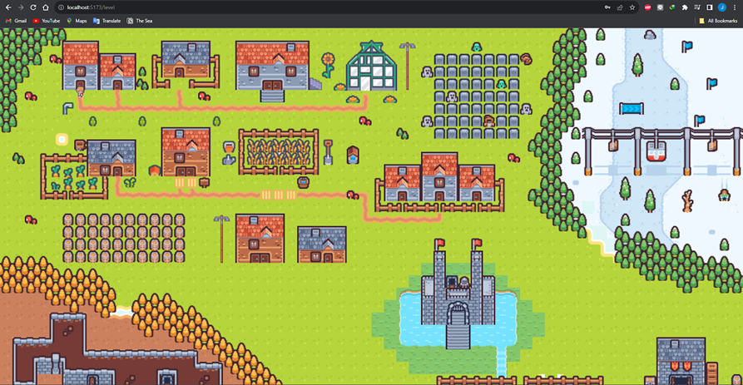

In-Game Design

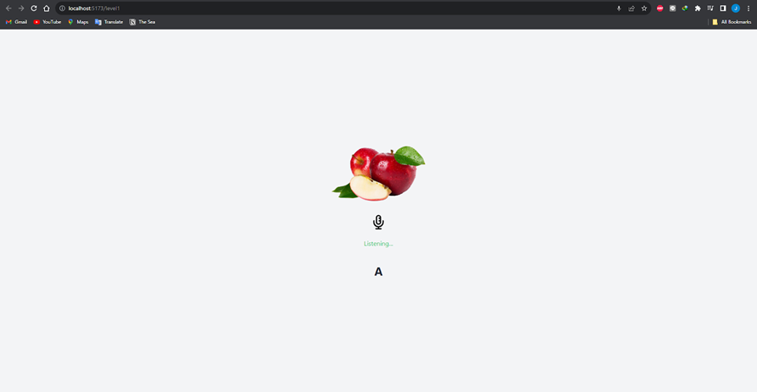

# 

# **Chapter 4 - Implementation**

## 4.1 Back-End

### 4.1.1 User Data Schema

| // User model interface IUser {  fullname: string;  username: string;  email: string;  password: string;  progress: number; }  module.exports = mongoose.model<IUser>('user_cred', **new** mongoose.Schema<IUser>({  fullname: { type: String, required: **true** },  username: { type: String, required: **true**, unique: **true** },  email: {type: String, required: **true**, unique: **true**},  password: { type: String, required: **true** },  progress: {type: Number}, })); |
| --- |

### 4.1.2 User Login

| **async** **function** **login**(req: any){  **const** { username, password } = req.body;  **const** user = **await** User.findOne({ username: username });   **if** (!user) {  **return** { error: 'Invalid credentials' };  }   **const** isPasswordValid = **await** bcrypt.compare(password, user.password);   **if** (isPasswordValid) {  **const** token = jwt.sign({ username: username }, secret, { expiresIn: '1h' });  **return** { token:token, progress:user.progress };  } **else** {  **return** { error: 'Invalid credentials' };  } } |
| --- |

### 4.1.3 User Register

| **async** **function** **register**(req: any){  **const** { fullname, username, email, password } = req.body;   **const** hashedPassword = **await** bcrypt.hash(password, 10);  **const** newUser = **new** User({ fullname: fullname, username: username, email: email, password: hashedPassword, progress: 0 });  **await** newUser.save();  **return** { message: 'User registered successfully' }; } |
| --- |

### 4.1.4 User Progression Tracking

| **async** **function** **updateProgress**(req: any) {  **const** { progress } = req.body;  **const** token = req.headers["x-access-token"];    **let** decoded = **null**;    **try** {  decoded = jwt.verify(token, "RPLexia") **as** JwtPayload;  console.log(decoded);  } **catch** (error) {  console.log(error);  **return** { error: "Invalid token"};   }    **const** user = **await** User.findOneAndUpdate({ username: decoded.username }, {progress: progress}, {  new: **true**  });    **if**(!user){  **return** { error: "User not found"};  }**else**{  console.log(user);  **return** { message: "Progress updated successfully", progress: user.progress};  } } |
| --- |

## 4.2. Game Script

### 4.2.1. Player Movement

extends CharacterBody2D

@export var SPEED = 50

@export var INVENTORY: Inventory

@onready var axis = Vector2.ZERO

@onready var animations = $AnimatedSprite2D

var lastDirection = "Down"

func _ready():

animations.play("IdleDown")

func _physics_process(delta):

player_movement(delta)

func player_movement(delta):

axis = Input.get_vector("Left", "Right", "Up", "Down")

velocity = axis * SPEED

handle_move()

handle_idle()

move_and_slide()

func handle_move():

if(velocity.x < 0 and velocity.y < 0):

animations.play("MoveUpLeft")

lastDirection = "UpLeft"

elif(velocity.x < 0 and velocity.y > 0):

animations.play("MoveDownLeft")

lastDirection = "DownLeft"

elif(velocity.x > 0 and velocity.y < 0):

animations.play("MoveUpRight")

lastDirection = "UpRight"

elif(velocity.x > 0 and velocity.y > 0):

animations.play("MoveDownRight")

lastDirection = "DownRight"

elif(velocity.x < 0):

animations.play("MoveLeft")

lastDirection = "Left"

elif(velocity.x > 0):

animations.play("MoveRight")

lastDirection = "Right"

elif(velocity.y < 0):

animations.play("MoveUp")

lastDirection = "Up"

elif(velocity.y > 0):

animations.play("MoveDown")

lastDirection = "Down"

func handle_idle():

if(velocity == Vector2.ZERO):

if(lastDirection == "Down"):

animations.play("IdleDown")

elif(lastDirection == "DownRight"):

animations.play("IdleDownRight")

elif(lastDirection == "DownLeft"):

animations.play("IdleDownLeft")

elif(lastDirection == "Up"):

animations.play("IdleUp")

elif(lastDirection == "UpLeft"):

animations.play("IdleUpLeft")

elif(lastDirection == "UpRight"):

animations.play("IdleUpRight")

elif(lastDirection == "Left"):

animations.play("IdleLeft")

elif(lastDirection == "Right"):

animations.play("IdleRight")

### 4.2.2. Map Triggers

extends Node2D

@onready var location = $Player.position

var JavaScript = Engine.get_singleton("JavaScript")

var saved_index : int

var houses : PackedVector2Array

# Called when the node enters the scene tree for the first time.

func _ready():

houses.append(Vector2(104, 82))

houses.append(Vector2(152, 82))

houses.append(Vector2(232, 66))

# Called every frame. 'delta' is the elapsed time since the previous frame.

func _process(delta):

location = $Player.position

var index = 1

for loc in houses :

if(((loc.x - location.x)**2 + (loc.y - location.y)**2) < 1):

if(saved_index != index):

saved_index = index

if OS.get_name() == "HTML5":

var command = "window.location.href='http://localhost:5173/level" + str(index)

JavaScript.eval(command)

else:

var url = "http://localhost:5173/level" + str(index)

OS.shell_open(url)

index += 1

# 

# **Chapter 5 - Test Plan and Testing**

## 5.1 Introduction

Lexia implements standard software testing and test plan documentation procedures in order to validate our product. Lexia employs a multi-faceted approach, integrating cutting-edge technologies such as Godot, ReactJS, NodeJS, speech recognition, text-to-speech, and intelligent character recognition powered by TensorFlow. This unique combination of tools aims to provide an engaging and effective platform for dyslexic users to practice and improve their language abilities.

Our primary goal is to ensure the seamless functionality, usability, and reliability of Lexia. This document outlines the systematic approach we will adopt to thoroughly test each module, feature, and interaction within the game. Our testing strategy encompasses a range of scenarios to address both common and edge cases, ensuring that Lexia remains a robust and accessible tool for its target audience.

### 5.1.1 Scope

#### 5.1.1.1 In Scope

The scope of testing defines the features, functional or non-functional requirements of the software that will be tested. The primary purpose is to establish a clear understanding of what aspects will be examined and validated to ensure the software’s reliability and effectiveness.

* Features Testing

Text to Speech Feature

This feature uses auditory feedback to help users understand words better. It says words out loud and gives extra information to make it easier for users to understand. Testing this feature makes sure it says words right, works well, and fits smoothly into the dyslexia assistance game.

Speech Recognition Feature

The Speech Recognition feature is designed to evaluate whether individuals with dyslexia pronounce words correctly with the right articulation. This feature listens to users when they speak and provides feedback on their pronunciation. Testing the Speech Recognition feature ensures its accuracy and effectiveness within the dyslexia assistance game.

OCR (Optical Character Recognition) Feature

The Speech Recognition feature is designed to evaluate whether individuals with dyslexia pronounce words correctly with the right articulation. This feature listens to users when they speak and provides feedback on their pronunciation.

Word Segmenter

The Word Segmenter feature in this game helps dyslexic individuals by breaking down long words into smaller, more manageable segments. This feature supports users who find long words overwhelming and also plays a role in a game where users connect segmented words to form complete words.

* Functional Requirements Testing

Device Compatibility:

Confirm that the dyslexia assistance game is compatible with various devices commonly used by your target audience. This includes but is not limited to desktop computers, laptops, tablets, and smartphones.

Browser Compatibility

Validate that the game works seamlessly across different web browsers, ensuring compatibility with popular choices such as Google Chrome, Mozilla Firefox, Safari, and Microsoft Edge.

Accessibility

Compliance with Accessibility Standards

Verify that the dyslexia assistance game complies with accessibility standards to ensure that users with dyslexia can navigate, interact, and benefit from the software without unnecessary barriers.

Adaptive Features Testing

Test adaptive features designed for accessibility, such as text-to-speech and word segmentation, to ensure they are effective and user-friendly for individuals with dyslexia

Customization Options

Difficulty Settings

Ensure that users can adjust the difficulty levels within the dyslexia assistance game to cater to various skill levels and individual preferences.

Modes and Levels

Validate the functionality of different modes and levels within the game, allowing users to choose an experience that suits their learning needs.

* Non-Functional Requirements Testing

Performance

Evaluate the responsiveness, loading times, and overall smooth operation of the dyslexia assistance game. Ensure that user interactions are prompt, loading times are reasonable, and the game operates seamlessly without lags or interruptions.

Scalability

Test the Lexia’s capacity to handle an increasing number of users without significant performance decline. Assess its ability to manage and process user data efficiently, and monitor resource utilization (CPU, memory, etc) during various activities.

#### 5.1.1.2 Out of Scope

Educational Curriculum

In making our dyslexia assistance game, we decided to focus on certain things. We won't be adding an expansion of the curriculum beyond the core focus on reading, writing, and speaking skills. We want to really help with the basic skills that dyslexic individuals find tricky. We won't be adding different subjects because we want the game to be all about improving reading, writing, and speaking for dyslexic users.

Looking to the future, we might think about letting users choose what they want to learn. Right now, we're not working with schools, but in the future, we might do that to make the game even better.

Advanced Language Support

Our dyslexia assistance game is designed to help with reading, writing, and speaking, and we've set some limits on what we're doing with languages.

Firstly, we won't be translating the game into lots of different languages beyond what we've already decided. We want to make sure the game is good in the languages we've chosen and not spread too thin. Also, we won't be adding really advanced language learning features for now. Our main focus is on helping with the basic skills dyslexic individuals need, and we want to do that really well.

### 5.1.2 Quality Objective

Our main aim in this testing project is to make sure that the dyslexia assistance game, also known as the "Application Under Test" (AUT), reaches a high level of quality. The goal is to provide effective support for people with dyslexia, helping them with reading, writing, and speaking.

Meeting Functional and Non-Functional Requirements

We're committed to checking that the dyslexia assistance game (AUT) does what it's supposed to do. This includes ensuring that all features work as intended, compatibility is maintained, and performance meets accepted standards.

Ensure the AUT meets the Client Standards

Living up to Client Standards

Our testing is all about not just meeting but exceeding the standards set by our client. We carefully evaluate the dyslexia assistance game (AUT) to ensure it not only does its job but goes beyond what users expect.

Identification and Resolution of Bugs/Issues:

One of our top priorities is finding and fixing any issues or bugs in the dyslexia assistance game (AUT) before it goes live. This way, when users get their hands on it, everything runs smoothly without any frustrating glitches.

### 5.1.3 Roles and Responsibilities

* Developers

Developers are the architects behind the construction and maintenance of the dyslexia assistance game. Here are the details:

Juan Jonathan - Project Coordinator and Tester

Responsibilities:

* Coordinate project schedules, resources, equipment, and information
* Break projects into doable actions and set timeframes
* Identify and define project requirements, scope, and objectives
* Ensure that objectives are met as the project evolves

Lauren Christy - UI/UX and Asset Designer and Front-End Programmer

Responsibilities:

* Research resources and references for the style of the game
* Design the UI with user experience in mind
* Design the storyboard
* Search for art, sound effects, and music assets
* Assign all of the sound assets to the corresponding gameplay
* Implement front-end programming to ensure seamless user interactions

Zaki Ananda - Game Designer and Back-End Programmer

Responsibilities:

* Develop the initial prototype
* Develop and implement game software
* Ensure that the game design is fully implemented and works as expected
* Create the concept of the game
* Test Manager  
  Lauren Christy

Responsibilites:

Test Managers serve as overseers of the testing process, crafting and executing the overarching strategy to meet testing goals. Tasked with the allocation of responsibilities among the testing team, they closely monitor and report on the progress of testing activities.

* QA Analyst

Zaki Ananda  
Responsibilities:

QA Analysts are pivotal in upholding the quality standards of the dyslexia assistance game. They play a central role in meticulously testing the application to unearth bugs, glitches, and areas for improvement

## 5.2 Test Methodology

### 5.2.1 Overview

For the purpose of testing the product being developed, we will be using agile methodology. As the development is done incrementally in many short cycles, testing will be done at the end of each cycle. This ensures that every new feature and change is implemented properly. The nature of agile methodology also allows us to be adaptive in response to changing requirements, as new ideas or feedback can be easily integrated with the existing development, and its impact be compared with the previous build.

The testing will be done in 6 different levels. Four of those levels will be done during the development phase. These are Unit Testing, Integration Testing, Regression Testing, and Alpha Testing. Meanwhile, the other two levels, Acceptance Testing and Beta Testing, will be done during the QA phase, nearing release. Each test level has its own test suite, test goals, and test result, the details of which are explained in Section 5.2.2.

After the end of the testing process, every bug and errors that it has encountered must then be identified to ensure they are valid, reproducible, and not a duplicate of other, reported bugs. They are then classified according to its severity (how it affects the application) and its priority (how urgent is it). The bugs are then assigned to various members of the development team, in order to investigate and fix them. The details of the bug triage process are explained on Section 5.2.3.

### 5.2.2 Test Levels

The software consists of codes made in two different languages: Javascript and GDScript. For Javascript code, testing frameworks such as Mocha and Cypress will be used. For Godot code, GDUnit will be used.

In the development phase of the game, the testing will consist of 4 levels

1. Unit Testing

In this test level, individual components such as Javascript’s modules and Godot’s scenes will be tested. The goal of this test is to ensure that every individual unit will behave properly. The test suite will consist of simple inputs to its component and its expected output. The test result will be the report of which component passed the unit test, which component didn’t, and which test is the issue.

1. Integration Testing

In this test level, a group of components will be tested as a whole. The goal of this test level is to ensure that the whole group will behave and interact with each other properly. The test suite will consist of multiple inputs to different components, and each component’s expected output. It is important to note that this test level only concerns the intra-language module (ie: a group of Javascript modules and a group of Godot scenes are tested separately). The test result will be the report of which group passed the unit test, which group didn’t, and which test is the issue.

1. Regression Testing

In this test level, the new build will be tested and compared with the previous build. The goal of this test level is to find any functional difference between the new build and the previous build. The test suite will consist of simple input and the previous build’s testing result. After testing, any difference of output will then be noted and needs to be investigated further before bug triage, as such changes might be intentional or irrelevant. The regression testing suite must be updated regularly on every build release to reflect the modification made on the new build. Thus, the test result will be the report of which test yielded a matching result, which test yielded a different result, further investigation on the test that yields different result, and the suggested addition to be made on the testing suite for the newer release.

1. Alpha Testing

In this test level, the new build will be tested manually by the developer. The goal of this test level is to ensure that the whole system runs according to the developer's expectations. The test suite will consist of pre-defined states on both the front-end and the game application, with the expected behavior. The test result will be the recorded gameplay by the developer, and comments on each section of the application.

In the QA phase of the game, in addition to the aforementioned 5 levels of testing, the testing will consist of 2 more levels.

1. Acceptance Testing

In this test level, the build will be tested by the developer and our in-house target audience. The goal of this test level is to ensure that the build can meet user expectations and requirements, and to confirm that it is fit for the beta release. The testers will play the game and interact with it however they want, with very minimal feedback from the developer. This ensures that the developer will be aware of the typical player’s instinct and adjust the game accordingly. The test result will be the recorded gameplay by the tester, and a survey about their experience.

1. Beta Testing

In this test level, the build will be tested by a selected group of external target audience. The goal of this test level is to ensure that it is fit for the public release. Similar to the acceptance testing, the testers will play the game with minimal feedback. The test result will be the recorded gameplay by the tester, and a survey about their experience.

### 5.2.3 Bug Triage

After the testing has finished, the bug triage process will begin. This process will turn the testing report into typically many bug reports. It is divided into three stages.

1. Validation

During the validation stage, the bugs recorded on the testing report will be tested for its validity and reproducibility. Once it passes, it will be compared to existing bug reports, and if it is not a duplicate, it will be assigned to a JIRA issue tracker. If it is a duplicate, then its details will be added as a further comment on the existing issue tracker. This stage will be done after the testing phase, and before the sprint review.

The following is the general outline for a bug report to be posted on a JIRA issue tracker

* Title
* Affected Component
* Environment
* Description
  + Overview
  + Logs, stack trace, or any other useful file
* Reproducible steps
* Actual Result
* Expected Result

1. Classification

In the sprint review, the bugs that have been validated after the previous stage will be discussed in order to classify them according to their severity and priority. The following is the severity and priority scheme used for classification.

| Severity | Description |
| --- | --- |
| Critical | Bugs have severe impact that could cause damage or loss of data |
| Major | Bugs have severe impact that could cause crashes or disruption |
| Moderate | Bugs have noticeable impact that would affect most use case |
| Minor | Bugs have minimal impact that would affect some or edge use case |
| Cosmetic | Bugs do not impact functionality at all |

| Priority | Description |
| --- | --- |
| Urgent | Bugs need to be addressed and resolved as soon as possible |
| High | Bugs need to be addressed before next sprint |
| Medium | Bugs can be deferred for now but need to be addressed whenever possible |
| Low | Bugs can be safely ignored but must to be fixed before release |

1. Assignment

In the sprint review, after the bugs have been classified according to its severity and urgency, they then will be assigned to various members of the development team, according to their job desk, as described in Section 1.3. Each team member is then responsible for investigating and fixing the bugs that have been assigned to them, and must report their findings on the next sprint review.

### 5.2.4 Suspension Criteria and Resumption Requirements

Suspension criteria outline the conditions under which all or specific parts of the testing procedure should be temporarily halted. These criteria are defined to ensure that testing is paused when certain circumstances may compromise the validity or effectiveness of the testing process. The decision to suspend testing may be based on factors such as critical defects, unavailability of essential resources, or unexpected environmental issues.

The suspension criteria of Lexia includes :

1. Critical Defects

The identification of critical defects that significantly impede the core functionality of Lexia. For example, if a critical defect is identified where the speech recognition module consistently fails to accurately interpret user input, causing a significant hindrance to the core functionality of Lexia, the testing procedure may be suspended until this critical issue is resolved.

1. Resource Unavailability

Unforeseen unavailability of key testing resources or environments necessary for conducting thorough testing. For example, in the event of sudden server outages or unavailability of the NodeJS backend, testing may be suspended until the backend infrastructure is restored, ensuring that the testing team can fully assess the game's functionality in its intended environment.

1. Security Concerns

The discovery of potential security vulnerabilities that require immediate attention and resolution. For example, if a vulnerability assessment reveals a critical security flaw in the text-to-speech module that could potentially compromise user data, testing may be suspended to address and mitigate the security concern.

Resumption requirements define the conditions that must be met before testing can resume after a suspension. These requirements are established to ensure that testing recommences only when the identified issues have been adequately addressed, and the testing environment is conducive to effective evaluation.

The suspension criteria of Lexia includes :

1. Defect Resolution

All critical defects identified during the suspension period must be addressed, and fixes validated to ensure they do not introduce new issues. For example, once the critical defect in the speech recognition module is addressed, the testing team should verify that the fix is effective, and re-run relevant test cases to ensure that the functionality is restored without introducing new issues.

1. Resource Availability

Ensure that the necessary testing resources and environments are once again accessible and in a stable state for testing to resume. For example, after the NodeJS backend server is back online and stable, testing can resume. It's important to confirm that all necessary resources, including databases and APIs, are accessible for comprehensive testing of Lexia's features.

1. Security Mitigation

If the suspension was due to security concerns, implement and validate appropriate security measures before resuming testing. For example, if testing was suspended due to a security concern in the text-to-speech module, resumption may require the implementation of security patches or updates. Subsequent testing should validate that the security measures have been successfully applied and do not introduce vulnerabilities.

### 5.2.5 Test Completeness

In order to ascertain that the testing process for Lexia is comprehensive and thorough, it is imperative to establish clear Test Completeness Criteria. These criteria serve as benchmarks to determine when testing can be considered complete and the software is ready for release.

1. 100% Test Coverage

This entails systematically executing test cases that cover all critical features, modules, and functionalities of Lexia. The goal is to ensure that every aspect of the software has been rigorously tested, encompassing various user interactions, game scenarios, and backend processes.

1. All Manual & Automated Test Cases Executed

This involves validating the functionality, usability, and performance of Lexia through a comprehensive set of test scenarios. By ensuring that both manual and automated tests are conducted and documented, the testing team can guarantee a thorough examination of the software.

1. All Open Bugs are Fixed or Will be Fixed in the Next Release

All reported bugs must be resolved and verified, or alternatively, there should be a documented plan outlining their resolution in the subsequent release. This step ensures that the software is free from critical issues that could impact its performance and user experience.

1. Adherence to Acceptance Criteria

This involves a thorough review of the initial project requirements and acceptance criteria to affirm that Lexia fulfills the specified objectives and functions as intended for users with dyslexia.

1. Performance Metrics Within Acceptable Range

Performance testing under various conditions must be conducted to ensure that Lexia remains responsive and performs optimally, with response times and resource utilization falling within expected parameters.

1. User Acceptance Testing (UAT) Completed Successfully

Obtaining confirmation from end-users or stakeholders that Lexia meets their expectations and requirements is essential. Conducting UAT sessions with representatives from the target user group ensures that the game aligns with their needs and preferences, providing valuable insights for the final release.

## 5.3 Resource & Environment Needs

### 5.3.1 Testing Tools

5.3.1.1 Trello

Trello is a project management tool that uses boards, lists, and cards to help teams organize and prioritize work. It's highly visual and flexible, making it easy to adapt to various project management styles. Trello can be employed to track and manage the progress of testing tasks, organize test cases, and collaborate on identifying and resolving issues. Boards can represent different testing phases, and cards can be used to detail specific test cases, defects, or testing milestones.

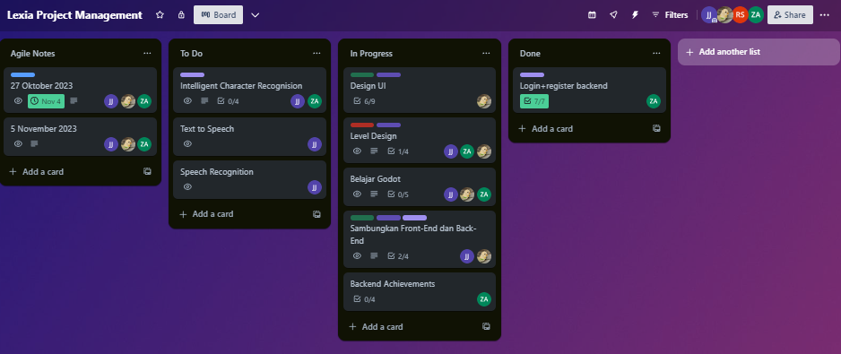

5.3.1.2 Postman

Postman is a collaboration platform for API development that simplifies the process of developing, testing, and documenting APIs. It provides an intuitive interface for sending HTTP requests and inspecting server responses. Postman can be utilized to test the API endpoints of the NodeJS backend in Lexia. Testers can create and execute API requests, validate responses, and ensure that communication between different components of the application is seamless



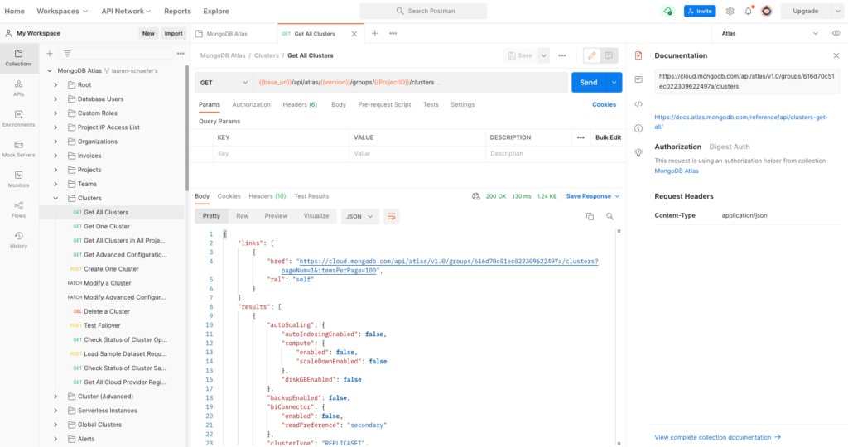

5.3.1.3 Tensorflow

TensorFlow is an open-source machine learning framework developed by Google. It's widely used for building and training machine learning models, including applications like intelligent character recognition. TensorFlow is crucial for the intelligent character recognition module in Lexia. It can be employed to train models that recognize and interpret characters in the context of the game. Testing with TensorFlow involves validating the accuracy and reliability of character recognition, ensuring a high level of performance for users with dyslexia.

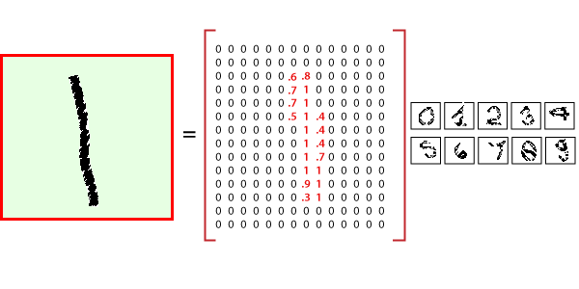

5.3.1.3 Selenium

Selenium is an open-source framework for automating web applications. It provides a way to interact with web browsers, simulate user actions, and automate testing of web applications. Selenium can be used to automate the testing of the ReactJS-based front end of Lexia. Testers can create scripts to simulate user interactions, such as navigating through the game, interacting with speech recognition and text-to-speech features, and ensuring that the user interface behaves as expected across different browsers.



## 5.4 Terms/Acronyms

| **TERM/ACRONYM** | **DEFINITION** |
| --- | --- |
| API | Application Program Interface |
| AUT | Application Under Test |
| QA | Quality Assurance |
| JIRA | Tools for tracking issues an bug report |

# 

# **Chapter 6 - Final Test Result**

## 6.1 Unit Testing Result

A python script is used for our unit testing via Selenium. Here, we can use Selenium web driver in order to give inputs to the web and check if the response is as expected. Below is the script we used :

from selenium import webdriver

from selenium.webdriver.common.keys import Keys

from selenium.webdriver.common.by import By

import time

import unittest

class RegisterTest(unittest.TestCase):

def setUp(self):

self.driver = webdriver.Chrome() # Update with the path to your chromedriver executable

self.driver.get('http://localhost:5173/register') # Update with the URL of your development server

def test_registration(self):

# Fill in form fields

self.driver.find_element(By.ID, 'fullname').send_keys('John Doe')

self.driver.find_element(By.ID, 'username').send_keys('john_doe')

self.driver.find_element(By.ID, 'email').send_keys('john@example.com')

self.driver.find_element(By.ID, 'password').send_keys('password123')

self.driver.find_element(By.ID, 'password-confirm').send_keys('password123')

# Click the register button

self.driver.find_element(By.CSS_SELECTOR, '[type="submit"]').click()

# Wait for the asynchronous registration process to complete

time.sleep(5) # You might need to replace this with more robust waiting strategies

# Perform assertions as needed

def tearDown(self):

self.driver.quit()

if __name__ == '__main__':

unittest.main()

Below are the results of our testing for React register component :

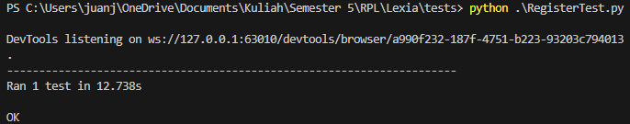

Using the script, we can ask python to be the webdriver to run our component. Selenium can find jsx elements in the component either by its ID or CSS_SELECTOR. Hence, we can send keys to the input elements and after that ‘click’ the register button classified as submit and send the request to the backend. As we can see, the test is run and the result is successful.

We then use a similar script to test the login page :

from selenium import webdriver

from selenium.webdriver.common.by import By

import time

import unittest

class LoginTest(unittest.TestCase):

def setUp(self):

self.driver = webdriver.Chrome()

self.driver.get('http://localhost:5173/login') # Update with the URL of your development server

def test_login(self):

# Fill in login form fields

self.driver.find_element(By.ID, 'username').send_keys('John Doe')

self.driver.find_element(By.ID, 'password').send_keys('password123')

# Click the login button

self.driver.find_element(By.CSS_SELECTOR, '[type="submit"]').click()

# Wait for the asynchronous login process to complete

time.sleep(5) # Replace this with more robust waiting strategies

# Perform assertions as needed

def tearDown(self):

self.driver.quit()

if __name__ == '__main__':

unittest.main()

Below are the results of our testing for React login component :

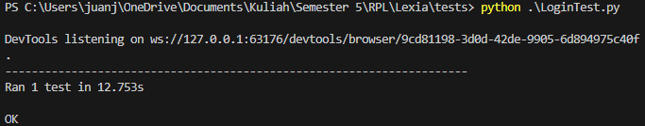

We can conclude by the unit test that our login and register components are working as expected.

## 6.2 Integration Testing Result

| ID | Test Case Objective | Test Case Description | Expected Result | Received Result |
| --- | --- | --- | --- | --- |
| 1 | Check the linking of Register and Login components | Insert unique credentials for a new account and click the register button | Redirect to Login component | Successful |
| 2 | Check the linking of Login dan Level component | Insert correct credentials of a valid account and | Redirect to Level component | Successful |
| 3 | Check if React iframe element can sandbox the HTML5 exported Godot game | Render the Level component | Level component renders properly and the game is playable | Successful |
| 4 | Check if Godot JavaScriptBridge is handling the page redirection on tilemap trigger properly | Walk to the door on some houses in the Godot game | Redirect to minigame levels (Level1, Level2, etc) components | Successful |
| 5 | Check speech recognition feature of levels minigame | Click on the microphone button and say the letters presented twice per letter | Each successful recognition moves to the next letter in the spelling | Successful |

Integration testing results :

1. Check the linking of Register and Login components

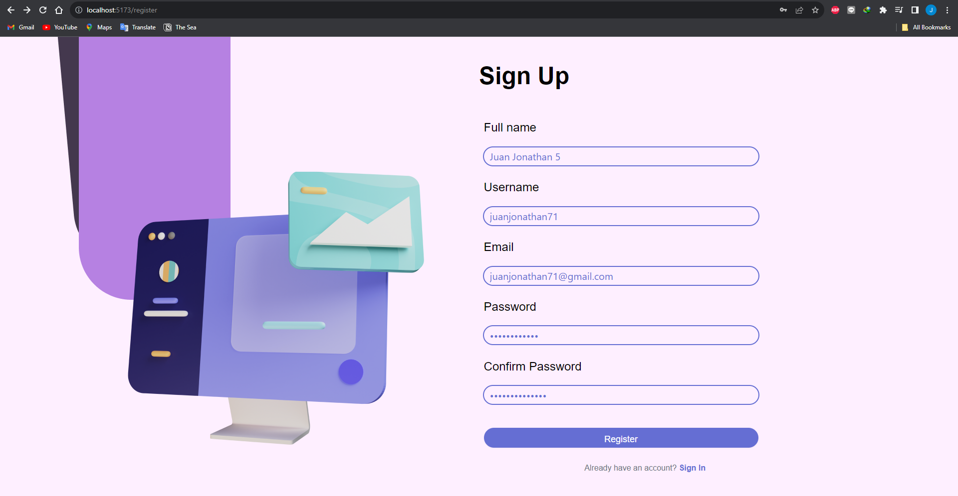

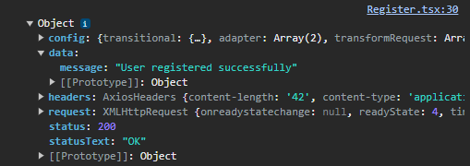

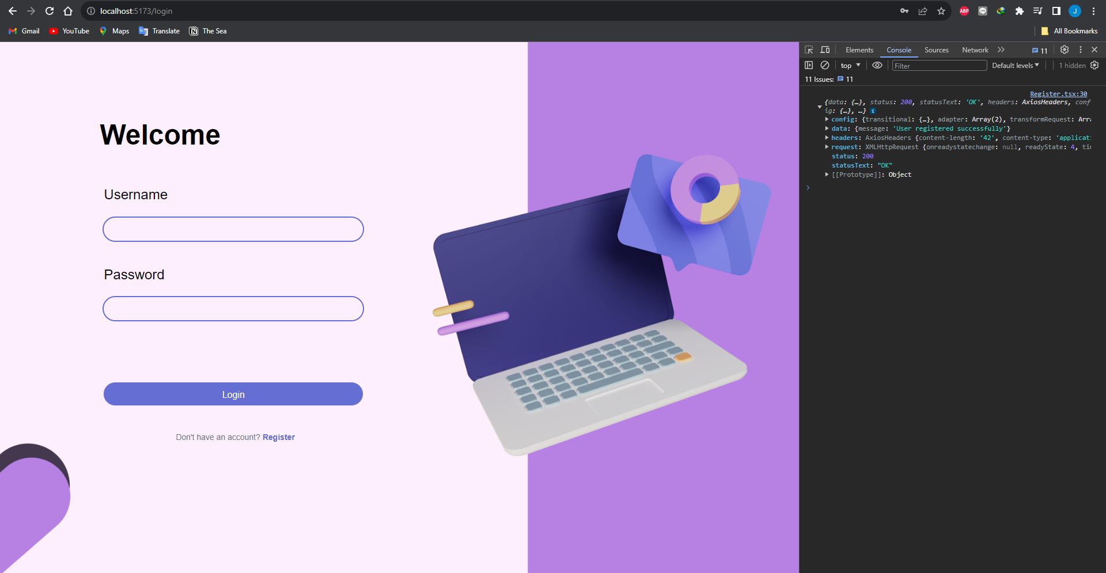

1. Check the linking of Login dan Level component

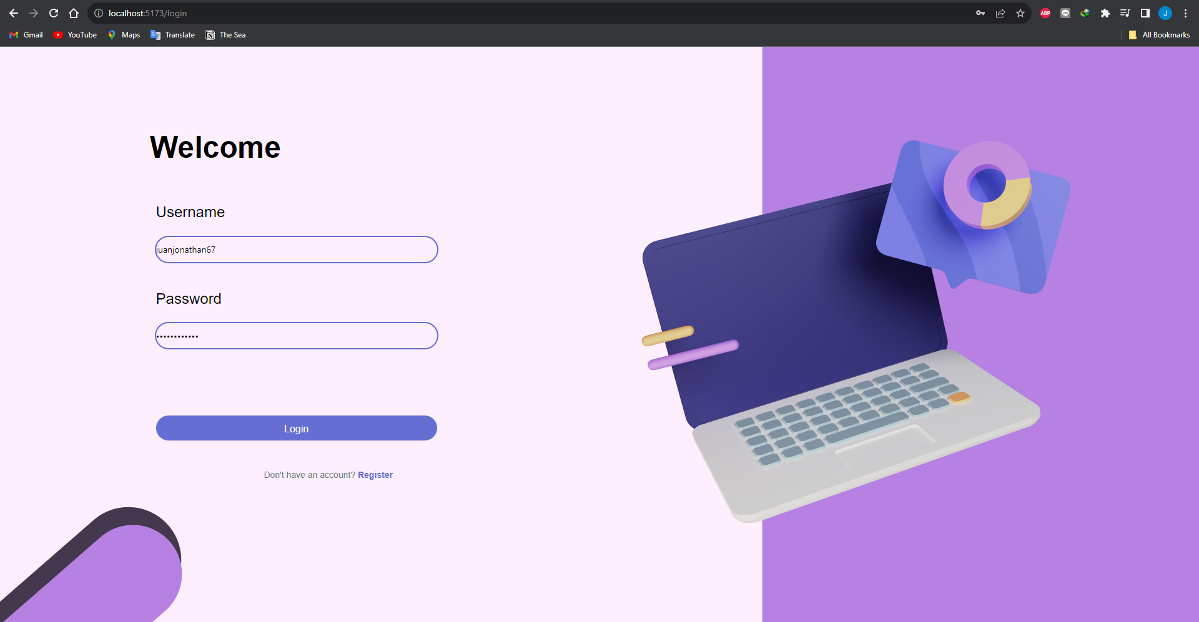



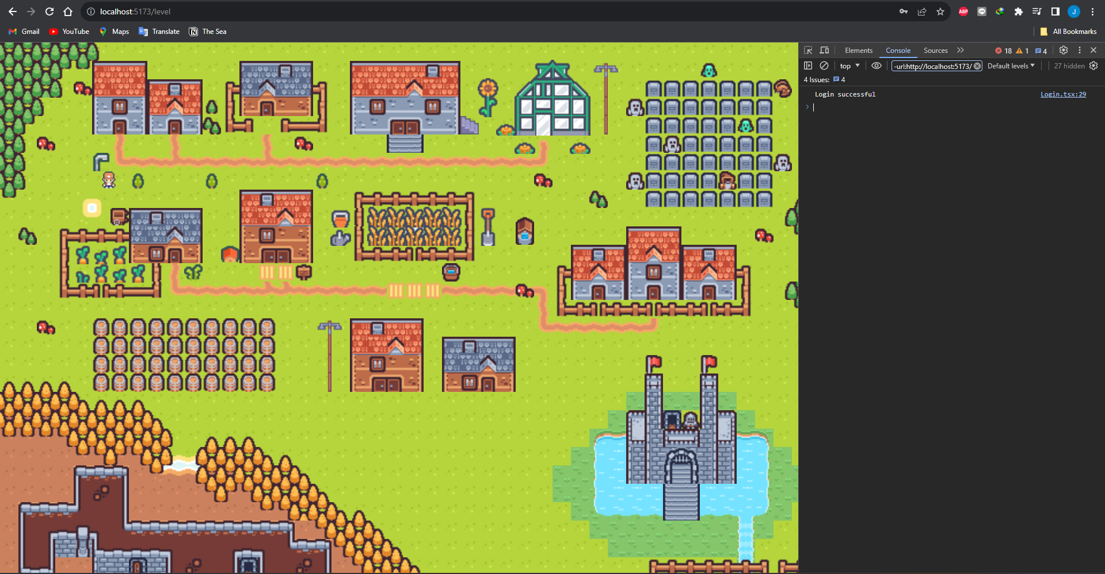

1. Check if React iframe element can sandbox the HTML5 exported Godot game

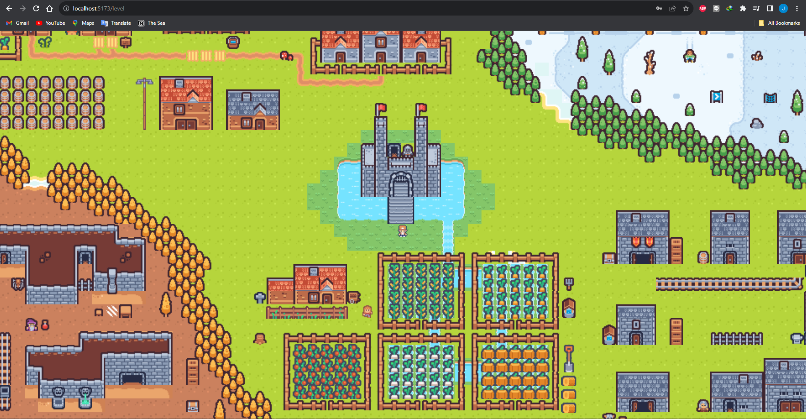

1. Check if Godot JavaScriptBridge is handling the page redirection on tilemap trigger properly

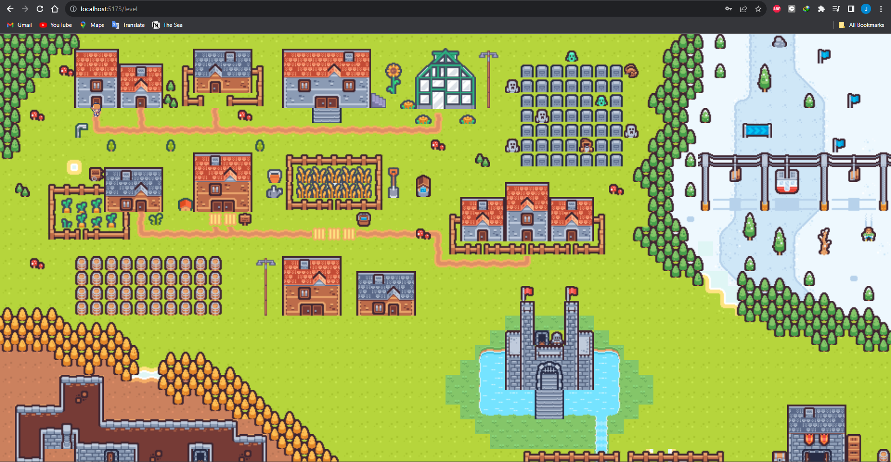

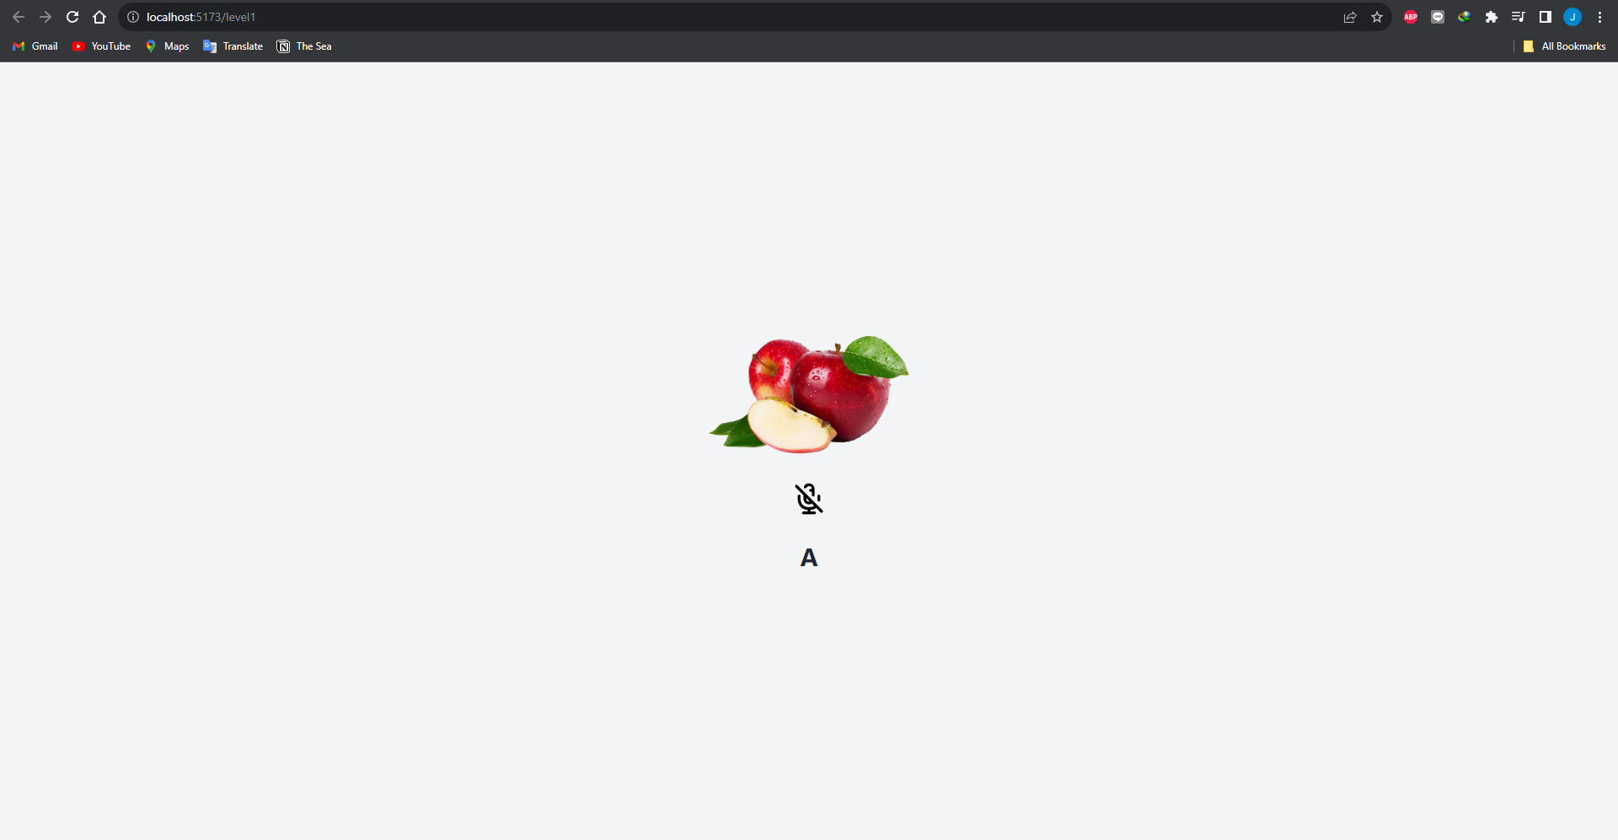

1. Check speech recognition feature of levels minigame

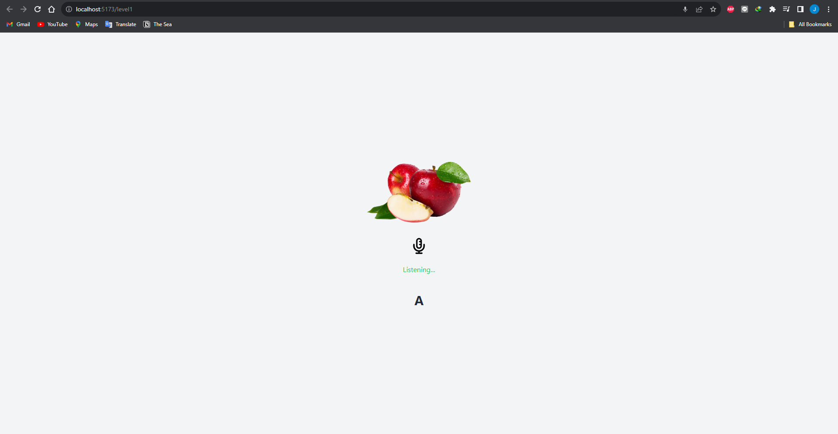

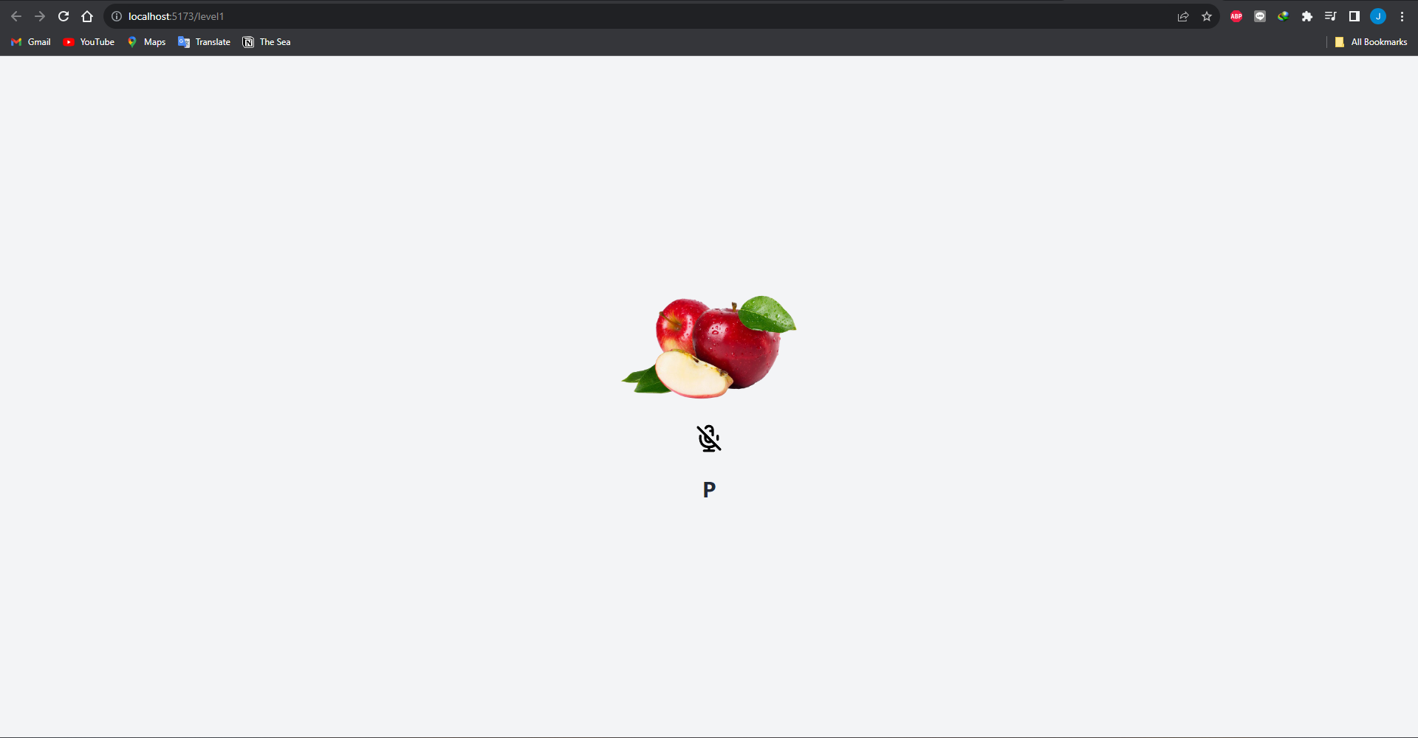

## 6.3 Regression Testing Result

Regression Testing is done for our project in order to make sure changes to the app does not break the functionality of the app, requiring a refactor. These tests should be modularly implemented according to the modularity of the app. As such, developers can simply rerun the tests and concludes that the newer version in the version control system passes the test and can be tagged as a stable release of the software.

Lexia uses this script in its regression testing :

import unittest

from selenium import webdriver

from selenium.webdriver.common.by import By

import time

class RegressionTests(unittest.TestCase):

def setUp(self):

self.driver = webdriver.Chrome()

self.base_url = "http://localhost:5173" # Update with your development server URL

def tearDown(self):

self.driver.quit()

def test_register_and_login(self):

# Test Registration

self.driver.get(self.base_url + "/register")

self.register_user("John Doe", "john_doe", "john@example.com", "password123")

# Test Login

self.driver.get(self.base_url + "/login")

self.login_user("john_doe", "password123")

def test_invalid_login(self):

# Test Login with invalid credentials

self.driver.get(self.base_url + "/login")

self.login_user("nonexistent_user", "invalid_password")

def register_user(self, fullname, username, email, password):

self.driver.find_element(By.ID, 'fullname').send_keys(fullname)

self.driver.find_element(By.ID, 'username').send_keys(username)

self.driver.find_element(By.ID, 'email').send_keys(email)

self.driver.find_element(By.ID, 'password').send_keys(password)

self.driver.find_element(By.ID, 'password-confirm').send_keys(password)

self.driver.find_element(By.CSS_SELECTOR, '[type="submit"]').click()

time.sleep(2) # Adjust wait time as needed

def login_user(self, username, password):

self.driver.find_element(By.ID, 'username').send_keys(username)

self.driver.find_element(By.ID, 'password').send_keys(password)

self.driver.find_element(By.CSS_SELECTOR, '[type="submit"]').click()

time.sleep(2) # Adjust wait time as needed

if __name__ == '__main__':

unittest.main()

Here are the results of our regression testing :

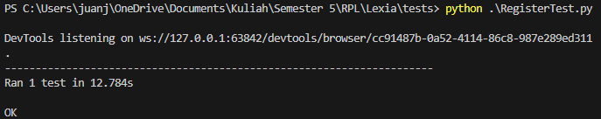

As we can see, the latest version of our software works perfectly after changes to the login and register system, as well as the newest export of the Godot powered game.

## 6.4 User Acceptance Testing

User acceptance testing is a critical phase where the early version of the web-based game will be provided to users for evaluation. Participants will have the opportunity to explore the game without extensive supervision and provide valuable feedback. The feedback will be collected through a structured survey.

Survey Questions:

1. How would you rate the overall gameplay experience?

* Very Enjoyable
* Enjoyable
* Neutral
* Unenjoyable
* Very Unenjoyable

1. Was it easy to understand the game mechanics and controls?

* Very Easy
* Easy
* Neutral
* Difficult
* Very Difficult

1. Did you encounter any issues or bugs while playing the game?

* No Issues
* Minor Issues
* Moderate Issues
* Major Issues
* Game-breaking Issues

1. How satisfied are you with the graphics and overall visual presentation of the game?

* Very Satisfied
* Satisfied
* Neutral
* Dissatisfied
* Very Dissatisfied

1. Please rate the performance of the game (speed, responsiveness).

* Excellent
* Good
* Average
* Poor
* Very Poor

1. Were you able to easily navigate through menus and find necessary information?

* Very Easy
* Easy
* Neutral
* Difficult
* Very Difficult

1. Overall, how satisfied are you with the web-based game?

* Very Satisfied
* Satisfied
* Neutral
* Dissatisfied
* Very Dissatisfied

1. Please provide any additional comments or suggestions for improvement:

[Free-text response]

Participants :

| Tester’s / Player’s Name | Survey Overall Score | Open Feedback |
| --- | --- | --- |
| Michael Winston Tjahaja | 4 / 5 | Enjoyed the storyline and quests. The achievements system is motivating. Encountered a minor bug in the crafting system. Graphics and performance are excellent. Looking forward to future updates. |
| Ahmad Rifqi | 4 / 5 | Found the controls easy to understand. Enjoyed exploring dynamic events. Suggested improvements in menu navigation. Overall satisfied with the game but wishes for more variety in quests. |
| Roy Oswaldha | 5 / 5 | Highly engaged with the achievements system. No issues encountered. Graphics and performance exceeded expectations. Excited about the crafting and economy features. |
| Bernanda Nautval Rai | 4 / 5 | Explored all features and provided positive feedback on the engaging storyline. Suggested adding more customization options for characters. Graphics and performance rated as excellent. |

# 

# **Chapter 7 - User Manual**

# 

# 

# 

# 

# 

# 

# 

# **Chapter 8 - MoU**

**SURAT PERJANJIAN KERJASAMA**

Surat Perjanjian Kerjasama Pembuatan Aplikasi “Lexia”, yang selanjutnya disebut **“Perjanjian”**, dibuat dan ditandatangani pada hari Minggu, 8 Oktober 2023 yang bertempat di Depok, oleh dan antara:

Nama : Juan Jonathan

Tempat, Tanggal Lahir : Jakarta, 21 Oktober 2003

Alamat : Jl. Tabing L35A, DKI Jakarta

No. KTP/SIM 3173012110030003

Nama : Lauren Christy Tanudjaja Tempat, Tanggal Lahir : Jakarta, 11 Oktober 2003

Alamat : Taman Depok Permai Blok E No. 7, Depok

No. KTP/SIM 3171035110030006

Nama : Zaki Ananda

Tempat, Tanggal Lahir : Jakarta, 27 Agustus 2003

Alamat : Jl. Gas No. 7 Klender, DKI Jakarta

No. KTP/SIM 3175062708030005

Dalam hal ini bertindak sebagai Tim Pengembang Perangkat Lunak (Grup 1 Mata Kuliah

Rekayasa Perangkat Lunak Universitas Indonesia 2023) dan selanjutnya disebut dengan

**“PIHAK PERTAMA”.**

Nama : Manuel Nursamsu

Tempat, Tanggal Lahir : Jakarta, 11 Januari 1995

Alamat : Jl. Tabing L35A, DKI Jakarta

No. KTP/SIM 3173010701950005

Dalam hal ini bertindak sebagai klien dan selanjutnya disebut dengan **“PIHAK KEDUA”.**

PIHAK PERTAMA dan PIHAK KEDUA selanjutnya secara bersama-sama akan disebut sebagai **“PARA PIHAK”** dan masing-masing akan disebut sebagai **“PIHAK”.**

Dengan ini PARA PIHAK telah sepakat untuk mengadakan kerjasama usaha dengan ketentuan-ketentuan yang diatur sebagai berikut ini :

**PASAL 1**

**RUANG LINGKUP KERJA SAMA**

1. Pihak Pertama menunjuk Pihak Kedua untuk melakukan pengujian dan evaluasi terhadap perangkat lunak “Lexia”.
2. Pihak Kedua setuju untuk melakukan pengujian sesuai dengan pedoman dan spesifikasi yang diberikan oleh Pihak Pertama.

**PASAL 2**

**JANGKA WAKTU**

1. Kerja sama ini dimulai pada tanggal 11 September 2023 dan berakhir pada tanggal 25 Desember 2023.
2. Pihak Kedua setuju untuk memberikan laporan hasil pengujian kepada Pihak Pertama pada atau sebelum tanggal berakhirnya kerja sama.

**PASAL 3**

**KOMPENSASI**

1. Sebagai imbalan atas layanan pengujian yang disediakan, Pihak Pertama akan membayar kepada Pihak Kedua sejumlah Rp. 500.000,- pada akhir kerja sama.

**PASAL 4 KEPEMILIKAN INTELEKTUAL**

1. Pihak Kedua mengakui bahwa semua hak kekayaan intelektual terkait dengan Perangkat Lunak tetap milik Pihak Pertama.
2. Pihak Kedua setuju untuk tidak menggunakan atau mengungkapkan informasi rahasia atau hak kekayaan intelektual Pihak Pertama tanpa izin tertulis sebelumnya.

**PASAL 5 KONFIDENSIALITAS**

1. Selama dan setelah berakhirnya kerja sama, Pihak Kedua setuju untuk menjaga kerahasiaan semua informasi yang diterima dari Pihak Pertama.

**PASAL 6**

**TANGGUNG JAWAB**

1. Pihak Kedua bertanggung jawab untuk setiap kerusakan atau kerugian yang disebabkan oleh kelalaian atau tindakan yang melanggar perjanjian ini.

**PASAL 7 PEMUTUSAN**

1. Kedua belah pihak setuju bahwa perjanjian ini dapat diakhiri oleh salah satu pihak dengan pemberitahuan tertulis kepada pihak lainnya jika terjadi pelanggaran serius terhadap kewajiban di dalam perjanjian ini.

**PASAL 8**

**HUKUM YANG BERLAKU**

1. Perjanjian ini diatur oleh hukum Indonesia dan setiap sengketa yang timbul dari atau terkait dengan perjanjian ini akan diselesaikan melalui mediasi atau arbitrase sesuai dengan peraturan yang berlaku.

**PASAL 9 PERUBAHAN PERJANJIAN**

1. Setiap perubahan atau tambahan terhadap perjanjian ini memerlukan persetujuan tertulis dari kedua belah pihak.

**PASAL 10 KETENTUAN PENUTUP**

1. Perjanjian ini mencakup keseluruhan perjanjian antara kedua belah pihak dan menggantikan segala perjanjian sebelumnya, baik secara lisan maupun tertulis.

**LEMBAR PENGESAHAN**

Surat Perjanjian Kerjasama ini telah dibaca, dimengerti dan disetujui oleh kedua belah pihak pada hari ini dan tanggal tersebut pada surat perjanjian kerja sama ini.

Jakarta, 8 Oktober 2023

**PIHAK PERTAMA**



Juan Jonathan Lauren Christy Tanudjaja Zaki Ananda

**PIHAK KEDUA**



Manuel Nursamsu

# 

# 

# **Chapter 9 - Future Work and Closing**

## 9.1. Future Work

### 9.1.1. Achievement System

One of the key components missing from our game is an achievements system. Achievements add depth and engagement to the gaming experience, providing players with tangible goals and rewards for their accomplishments. In the future, we plan to implement a comprehensive achievements system that caters to various playstyles and encourages players to explore different aspects of the game. Here are the planned types of achievements :

1. Exploration Achievements

Encourage players to discover hidden areas and uncover secrets within the game world.

1. Quest Achievements

Reward players for completing quests and progressing through the game's narrative.

### 9.1.2. Additional Gameplay Elements

While our game has made significant strides, there are still various gameplay aspects that require refinement and expansion.

1. Crafting and Economy

Expand the crafting system to include more diverse recipes and materials, fostering a robust in-game economy driven by player interactions.

1. Dynamic Events

Implement dynamic events that occur spontaneously within the game world, offering unique challenges and rewards to players who participate.

## 9.2. Closing

In conclusion, the journey of developing our web-based game has been both rewarding and enlightening. The identified areas of future work outlined in this chapter serve as a roadmap for ongoing development, ensuring that our game evolves to meet the expectations and desires of our player community.

As we move forward, we remain dedicated to delivering an immersive and captivating gaming experience, and we express our gratitude to the players and developers who have been a part of this journey. The future holds exciting possibilities, and we look forward to shaping the next chapter of our game's evolution.

# 

# **REFERENCES**

1. I. Rachmawati, K. D. Soegondo, P. Solek, “Demographic Characteristics, Behavioral Problems, and IQ Profiles of Dyslexic Children at Dyslexia Association of Indonesia during January-June 2019: A Quantitative Study”, Special Educational Conference 2019, Singapore.
2. G. Gambetta. (2022). *Fast-Paced Multiplayer (Part I): Client-Server Game Architecture*. <https://www.gabrielgambetta.com/client-server-game-architecture.html>
3. G. Gambetta. (2022). *Fast-Paced Multiplayer (Part II): Client-Side Prediction and Server Reconciliation*. <https://www.gabrielgambetta.com/client-side-prediction-server-reconciliation.html>
4. C. Stephen. (2009). Language Flow: Opening the subject. Cognitive Semiotics. 2009. 63-91. 10.3726/81608_63.
5. S. M. Daud and H. Abas, "'Dyslexia Baca' Mobile App -- The Learning Ecosystem for Dyslexic Children," 2013 International Conference on Advanced Computer Science Applications and Technologies, Kuching, Malaysia, 2013, pp. 412-416, doi: 10.1109/ACSAT.2013.87.
6. J. Linietsky and A. Manzur. (2023, 31 May). *Introduction*. <https://docs.godotengine.org/en/stable/about/introduction.html>
7. Docker Documentation. *Docker Overview*. <https://docs.docker.com/get-started/overview/>
8. TypeScript Documentation. *TypeScript for the New Programmer*. <https://www.typescriptlang.org/docs/handbook/typescript-from-scratch.html>
9. NodeJS Documentation. *About Node.js*. <https://nodejs.org/en/about>
10. React Homepage. *React*. <https://react.dev/>
11. Figma About. *About Figma*. <https://www.figma.com/about/>
12. The PostgreSQL Global Development Group. *What is PostgreSQL?* <https://www.postgresql.org/about/>
13. Github, Inc. *Overview*. <https://docs.github.com/en/desktop/overview>
14. Edd Coates. *Game UI Database*.. <https://www.gameuidatabase.com/index.php>
15. Microsoft. *Get Started With Visual Studio Code*. <https://code.visualstudio.com/learn>
16. Pixelshell. *Freesound*. <https://freesound.org/>
17. Kenney. *Assets · Kenney*. <https://www.kenney.nl/tools>